INDEX

* Acknowledgement
* Frame 1 (Splash)
* Frame 2 (Login)
* Frame 3 (Home)
* Frame 4 (Apps)
* Frame 5 (Bulls and Cows)
* Frame 6 (Enter no.)
* Frame 7 (How to Play)
* Frame 8 (Contacts App)
* Frame 9 (Contacts Details)
* Frame 10 (Grizzly Bear Login)
* Frame 11 (Grizzly Bear Menu)
* Frame 12 (Grizzly Bear Bill)
* Frame 13 (Calculator App)
* Frame 14 (Next Prime No. App)
* Frame 15 (Setting App)
* Frame 16 (Change Background)
* Frame 17 (Change Avatar)
* Frame 18 (Security Setting)
* Frame 19 (About Us)
* Backend Tables
* Bibliography

**ACKNOWLEDGEMENT**

**In the accomplishment of this project successfully, many people have best owned upon me their blessings and the heart pledged support, this time I’m utilizing to thank all the people who have been concerned with the project.**

**Primarily I would thank god for being able to complete this project with success. Then I would like to thank my principal Mrs. Shraddha Sudame and Informatics Practices teacher Mrs. Mili Guha whose valuable guidance has been the ones that helped me patch this project and make it full proof success. There suggestions and instructions has served as the major contributor towards the completion of the project.**

**Then I would like to thank my parents and friends who have helped me with valuable suggestions and guidance has been helpful in various phases of the completion of the project.**

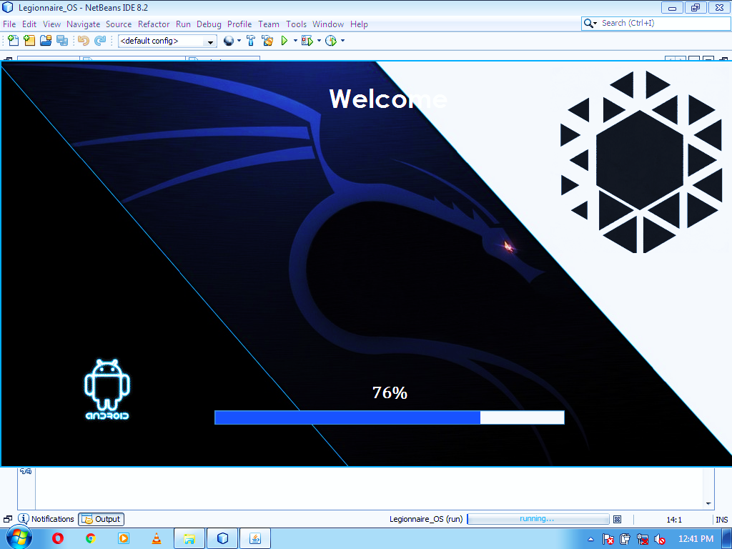**FRAME 1 (SPLASH)**

CODING:

CODED IN LEGIONNAIRE_OS. JAVA CLASS

package legionnaire_os;

import javax.swing.JOptionPane;

/* @author Mandeep M. Dalavi */

public class Legionnaire_OS {

public static void main(String[] args) {

Splash Splash = new Splash();

Login Login = new Login();

Splash.setVisible(true);

try{

for(int i = 0; i<=100; i++)

{

Thread.sleep(60);

Splash.loadingnum.setText(Integer.toString(i)+"%");

Splash.loadingbar.setValue(i);

if(i==100)

{

Splash.setVisible(false);

Login.setVisible(true);

}

}

}

catch(Exception e){

JOptionPane.showMessageDialog(Splash, "Error in Connectivity");

}

}

}

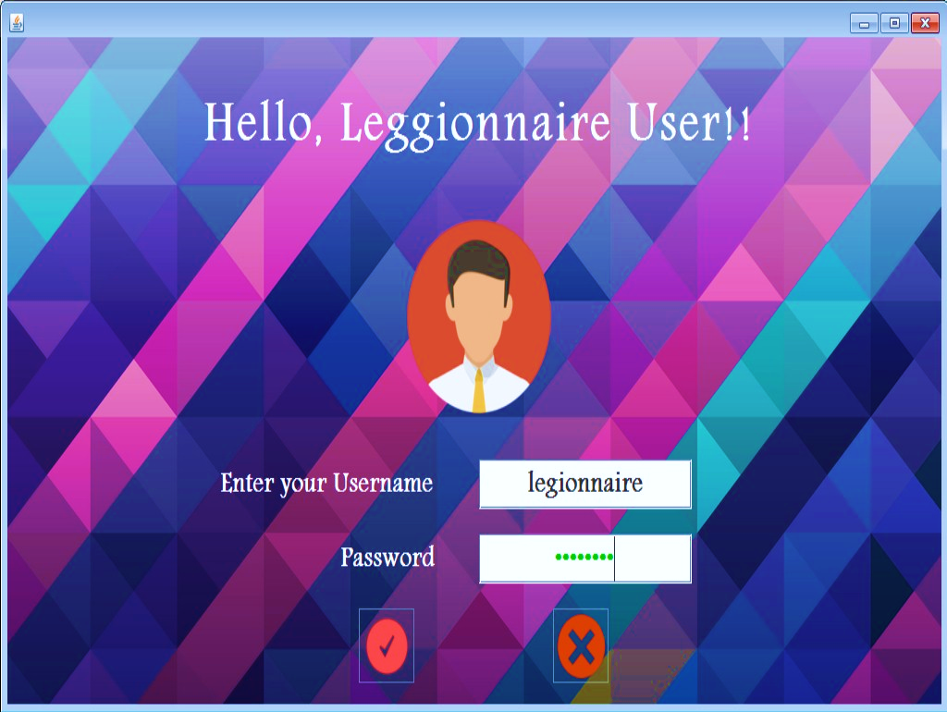**FRAME 2 (LOGIN)**

CODING:

package legionnaire_os;

/* @author Mandeep M. Dalavi */

import java.sql.*;

import javax.swing.ImageIcon;

import javax.swing.JOptionPane;

public class Login extends javax.swing.JFrame {

String curusername;

String curpassword;

public Login() {

initComponents();

//---------------------JDBC part getting username and password--------------------//

try {

Class.forName("java.sql.Driver");

Connection con = (Connection) DriverManager.getConnection("jdbc:mysql://localhost:3306/legionnaire", "root", "admin");

Statement stmt = (Statement) con.createStatement();

String query = "Select * from userpass";

ResultSet rs = stmt.executeQuery(query);

if (rs.first())

{

curusername = rs.getString(1);

curpassword = rs.getString(2);

}

}

catch (Exception e) {

JOptionPane.showMessageDialog(this, "Error in Connectivity!");

}

//------------------------JDBC part getting background--------------------------//

try {

Class.forName("java.sql.Driver");

Connection con = (Connection) DriverManager.getConnection("jdbc:mysql://localhost:3306/legionnaire", "root", "admin");

Statement stmt = (Statement) con.createStatement();

String query = "Select * from backgrounds";

ResultSet rs = stmt.executeQuery(query);

if (rs.first()) {

String loginbackg = rs.getString(2);

Loginlabel.setIcon(new ImageIcon(getClass().getResource(loginbackg)));

}

}

catch (Exception e) {

JOptionPane.showMessageDialog(this, “Error in Connectivity!”);

}

//----------------------------JDBC part getting avatar-----------------------------//

try {

Class.forName("java.sql.Driver");

Connection con = (Connection) DriverManager.getConnection("jdbc:mysql://localhost:3306/legionnaire", "root", "admin");

Statement stmt = (Statement) con.createStatement();

String query = "Select * from useravatar";

ResultSet rs = stmt.executeQuery(query);

if (rs.first()) {

String avatar = rs.getString(1);

Userlabel.setIcon(new ImageIcon(getClass().getResource(avatar)));

}

}

catch (Exception e)

{

JOptionPane.showMessageDialog(this, “Error in Connectivity!”);

}

-----------------------------------------------------------------------------------------------------------

private void SubmitbuttonActionPerformed(java.awt.event.ActionEvent evt) {

String user = UserTF.getText();

String pass = new String(PassTF.getPassword());

if (user.equalsIgnoreCase(curusername) && pass.equalsIgnoreCase(curpassword))

{

JOptionPane.showMessageDialog(this,"You have been successfully logged in." );

new Home().setVisible(true);

this.dispose();

}

else

{

JOptionPane.showMessageDialog(this, "Password and User ID do not match. Please try again.", "Incorrect username or password", JOptionPane.ERROR_MESSAGE);

}

}

-----------------------------------------------------------------------------------------------------------

private void CancelbuttonActionPerformed(java.awt.event.ActionEvent evt) {

if (JOptionPane.showConfirmDialog(this, "Are you sure you want to exit?", "Confirmation", JOptionPane.YES_NO_OPTION) == JOptionPane.YES_OPTION)

{

System.exit(0);

}

}

private void formWindowActivated(java.awt.event.WindowEvent evt) {

this.setResizable(true);

this.setSize(1026, 575);

}

-----------------------------------------------------------------------------------------------------------

private void PassTFMouseClicked(java.awt.event.MouseEvent evt) {

PassTF.setText("");

}

-----------------------------------------------------------------------------------------------------------

private void UserTFCaretUpdate(javax.swing.event.CaretEvent evt) {

String user = UserTF.getText();

if(user.equalsIgnoreCase(curusername)) {

UserTF.setForeground(Color.GREEN);

}

else {

UserTF.setForeground(Color.RED);

}

}

----------------------------------------------------------------------------------------------------------

private void PassTFCaretUpdate(javax.swing.event.CaretEvent evt) {

String pass = new String(PassTF.getPassword());

if(pass.equalsIgnoreCase(curpassword)) {

PassTF.setForeground(Color.GREEN);

}

else {

PassTF.setForeground(Color.RED);

}

}

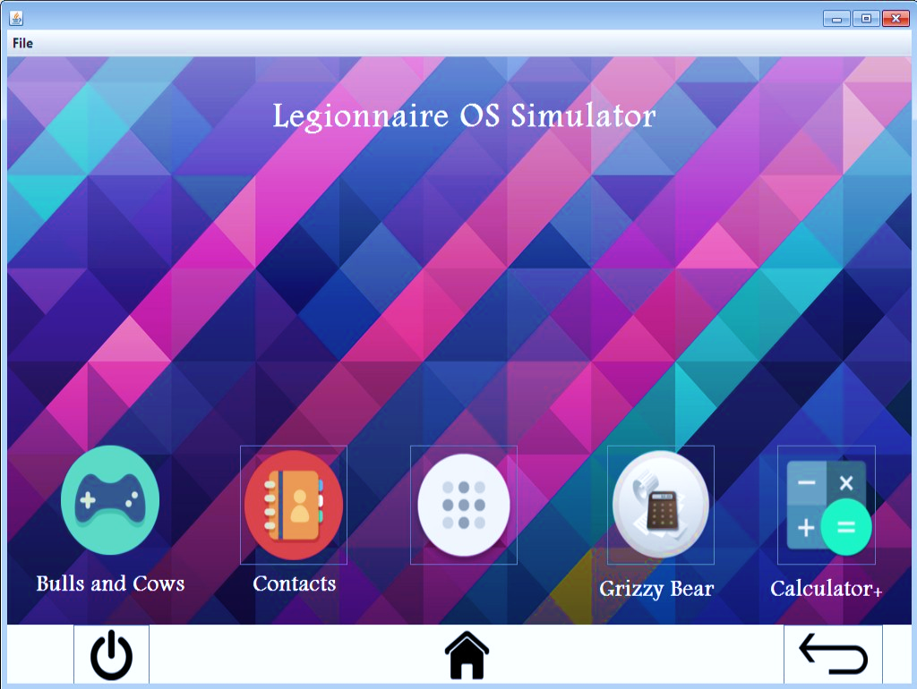**FRAME 3 (HOME)**

CODING:

package legionnaire_os;

import java.sql.*;

import javax.swing.ImageIcon;

import javax.swing.JOptionPane;

/* @author Mandeep M. Dalavi */

public class Home extends javax.swing.JFrame {

public Home() {

initComponents();

//-----------------------------JDBC part getting background--------------------------------//

try {

Class.forName("java.sql.Driver");

Connection con = (Connection) DriverManager.getConnection("jdbc:mysql://localhost:3306/legionnaire", "root", "admin");

Statement stmt = (Statement) con.createStatement();

String query = "SELECT * from Backgrounds";

ResultSet rs = stmt.executeQuery(query);

if (rs.first())

{

String homebackg = rs.getString(1);

Homelabel.setIcon(new ImageIcon(getClass().getResource(homebackg)));

}

}

catch (Exception e) {

JOptionPane.showMessageDialog(this, “Error in Connectivity!”);

}

}

private void BackbuttonActionPerformed(java.awt.event.ActionEvent evt) {

new Login().setVisible(true);

this.setVisible(false);

}

-----------------------------------------------------------------------------------------------------------

private void MenubuttonActionPerformed(java.awt.event.ActionEvent evt) {

new Apps().setVisible(true);

this.setVisible(false);

}

-----------------------------------------------------------------------------------------------------------

private void formWindowActivated(java.awt.event.WindowEvent evt) {

this.setResizable(true);

this.setSize(1026, 694);

}

-----------------------------------------------------------------------------------------------------------

private void JumpHomemenuActionPerformed(java.awt.event.ActionEvent evt) {

new Home().setVisible(true);

this.setVisible(false);

}

-----------------------------------------------------------------------------------------------------------

private void JumpAppmenuActionPerformed(java.awt.event.ActionEvent evt) {

new Apps().setVisible(true);

this.setVisible(false);

}

-----------------------------------------------------------------------------------------------------------

private void ExitOSmenuActionPerformed(java.awt.event.ActionEvent evt) {

if (JOptionPane.showConfirmDialog(this, "Are you sure you want to exit?", "Confirmation", JOptionPane.YES_NO_OPTION) == JOptionPane.YES_OPTION)

{

System.exit(0);

} }

-----------------------------------------------------------------------------------------------------------

private void PowerbuttonActionPerformed(java.awt.event.ActionEvent evt) {

if (JOptionPane.showConfirmDialog(this, "Are you sure you want to exit?", "Confirmation", JOptionPane.YES_NO_OPTION) == JOptionPane.YES_OPTION)

{

System.exit(0);

} }

-----------------------------------------------------------------------------------------------------------

private void HomebuttonActionPerformed(java.awt.event.ActionEvent evt) {

new Home().setVisible(true);

this.setVisible(false);

}

-----------------------------------------------------------------------------------------------------------

private void ContactsbuttonActionPerformed(java.awt.event.ActionEvent evt) {

new Contacts_App().setVisible(true);

this.setVisible(false);

}

-----------------------------------------------------------------------------------------------------------

private void GrizzyBearbuttonActionPerformed(java.awt.event.ActionEvent evt) {

new GrizzyBear_User_Login_Page().setVisible(true);

this.setVisible(false);

}

-----------------------------------------------------------------------------------------------------------

private void CalculatorbuttonActionPerformed(java.awt.event.ActionEvent evt) {

new Calculator_App().setVisible(true);

this.setVisible(false);

}

private void BullsandCowsbuttonActionPerformed(java.awt.event.ActionEvent evt) {

new Bulls_and_Cows().setVisible(true);

new Enter_no().setVisible(true);

this.setVisible(false);

}

-----------------------------------------------------------------------------------------------------------

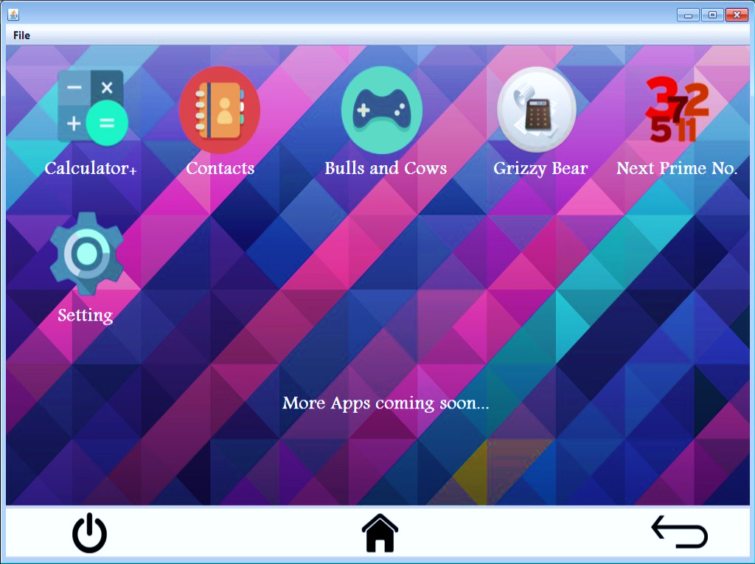**FRAME 4 (APPS)**

CODING:

package legionnaire_os;

import java.sql.*;

import javax.swing.ImageIcon;

import javax.swing.JOptionPane;

/* @author Mandeep M. Dalavi */

public class Apps extends javax.swing.JFrame {

public Apps() {

initComponents();

//----------------------------------JDBC part getting background--------------------------------//

try {

Class.forName("java.sql.Driver");

Connection con = (Connection) DriverManager.getConnection("jdbc:mysql://localhost:3306/legionnaire", "root", "admin");

Statement stmt = (Statement) con.createStatement();

String query = "SELECT * from Backgrounds";

ResultSet rs = stmt.executeQuery(query);

if (rs.first())

{

String homebackg = rs.getString(1);

Appslabel.setIcon(new ImageIcon(getClass().getResource(homebackg)));

}

}

catch (Exception e) {

JOptionPane.showMessageDialog(this, “Error in Connectivity!”);

}

}

private void SettingappActionPerformed(java.awt.event.ActionEvent evt) {

new Setting_App().setVisible(true);

this.setVisible(false);

}

-----------------------------------------------------------------------------------------------------------

private void BackbuttonActionPerformed(java.awt.event.ActionEvent evt) {

new Home().setVisible(true);

this.setVisible(false);

}

-----------------------------------------------------------------------------------------------------------

private void JumpHomemenuActionPerformed(java.awt.event.ActionEvent evt) {

new Home().setVisible(true);

this.setVisible(false);

}

-----------------------------------------------------------------------------------------------------------

private void JumpAppmenuActionPerformed(java.awt.event.ActionEvent evt) {

new Apps().setVisible(true);

this.setVisible(false);

}

-----------------------------------------------------------------------------------------------------------

private void ExitOSmenuActionPerformed(java.awt.event.ActionEvent evt) {

if(JOptionPane.showConfirmDialog(this, "Are you sure you want to exit?", "Confirmation", JOptionPane.YES_NO_CANCEL_OPTION)==JOptionPane.YES_OPTION)

{

System.exit(0);

}

}

private void CalculatorappActionPerformed(java.awt.event.ActionEvent evt) {

new Calculator_App().setVisible(true);

this.setVisible(false); }

-----------------------------------------------------------------------------------------------------------

private void ContactsappActionPerformed(java.awt.event.ActionEvent evt) {

new Contacts_App().setVisible(true);

this.setVisible(false);

}

-----------------------------------------------------------------------------------------------------------

private void GrizzyBearappActionPerformed(java.awt.event.ActionEvent evt) {

new GrizzyBear_User_Login_Page().setVisible(true);

this.setVisible(false);

}

-----------------------------------------------------------------------------------------------------------

private void NextPrimeNoappActionPerformed(java.awt.event.ActionEvent evt) {

new Next_Prime_No_App().setVisible(true);

this.setVisible(false);

}

-----------------------------------------------------------------------------------------------------------

private void PowerbuttonActionPerformed(java.awt.event.ActionEvent evt) {

if(JOptionPane.showConfirmDialog(this, "Are you sure you want to exit?", "Confirmation", JOptionPane.YES_NO_CANCEL_OPTION)==JOptionPane.YES_OPTION)

{

System.exit(0);

} }

-----------------------------------------------------------------------------------------------------------

private void HomebuttonActionPerformed(java.awt.event.ActionEvent evt) {

new Home().setVisible(true);

this.setVisible(false); }

private void formWindowActivated(java.awt.event.WindowEvent evt) {

this.setResizable(true);

this.setSize(1025, 707);

}

-----------------------------------------------------------------------------------------------------------

private void BullandCowsappActionPerformed(java.awt.event.ActionEvent evt) {

new Bulls_and_Cows().setVisible(true);

new Enter_no().setVisible(true);

this.setVisible(false);

}

-----------------------------------------------------------------------------------------------------------

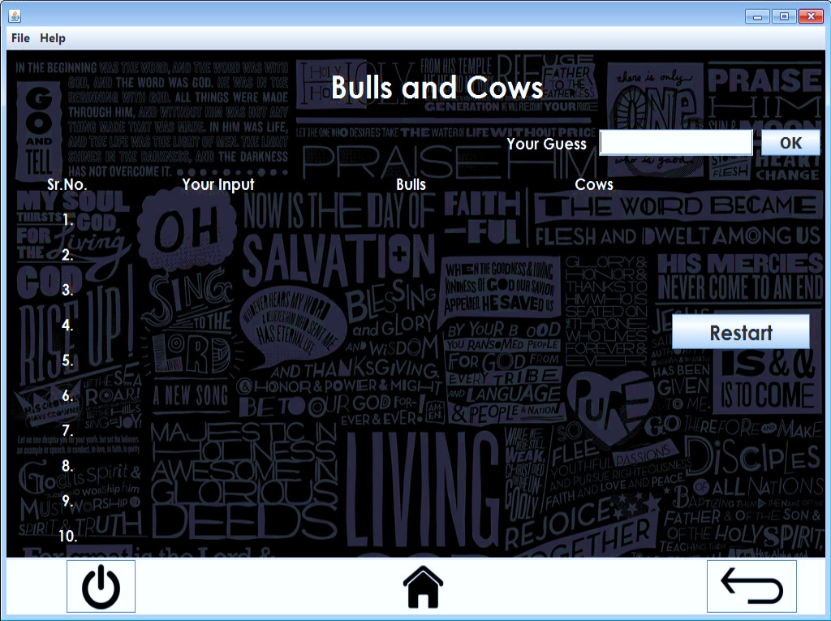**FRAME 5 (BULLS AND COWS)**

CODING:

package legionnaire_os;

import java.sql.*;

import javax.swing.JOptionPane;

/* @author Mandeep M. Dalavi */

-----------------------------------------------------------------------------------------------------------

public class Bulls_and_Cows extends javax.swing.JFrame {

int wordcount = 1;

int trycount = 1;

public Bulls_and_Cows() {

initComponents();

}

-----------------------------------------------------------------------------------------------------------

private void JumpHomemenuActionPerformed(java.awt.event.ActionEvent evt) {

new Home().setVisible(true);

this.setVisible(false);

}

-----------------------------------------------------------------------------------------------------------

private void JumpAppmenuActionPerformed(java.awt.event.ActionEvent evt) {

new Apps().setVisible(true);

this.setVisible(false);

}

-----------------------------------------------------------------------------------------------------------

private void ExitOSmenuActionPerformed(java.awt.event.ActionEvent evt) {

if(JOptionPane.showConfirmDialog(this, "Are you sure you want to exit?", "Confirmation", JOptionPane.YES_NO_CANCEL_OPTION)==JOptionPane.YES_OPTION)

{ System.exit(0); }

}

private void HomebuttonActionPerformed(java.awt.event.ActionEvent evt) {

new Home().setVisible(true);

this.setVisible(false);

}

-----------------------------------------------------------------------------------------------------------

private void BackbuttonActionPerformed(java.awt.event.ActionEvent evt) {

new Home().setVisible(true);

this.setVisible(false);

}

-----------------------------------------------------------------------------------------------------------

private void PowerbuttonActionPerformed(java.awt.event.ActionEvent evt) {

if(JOptionPane.showConfirmDialog(this, "Are you sure you want to exit?", "Confirmation", JOptionPane.YES_NO_CANCEL_OPTION)==JOptionPane.YES_OPTION)

{

System.exit(0);

}

}

-----------------------------------------------------------------------------------------------------------

private void formWindowActivated(java.awt.event.WindowEvent evt) {

this.setResizable(true);

this.setSize(1025, 707);

}

-----------------------------------------------------------------------------------------------------------

private void jButton1ActionPerformed(java.awt.event.ActionEvent evt) {

String input = inputTF.getText();

if (input.length() != 4)

{

JOptionPane.showMessageDialog(this, "Please enter a 4 digit word");

inputTF.setText(""); }

else

{

if (trycount <= 10)

{

int bulls = 0;

int cows = 0;

String word = new String();

char inputch;

char wordch;

try {

Class.forName("java.sql.Driver");

Connection con = (Connection) DriverManager.getConnection("jdbc:mysql://localhost:3306/legionnaire", "root", "admin");

Statement stmt = (Statement) con.createStatement();

String query = "Select word from words where srno=" + wordcount;

ResultSet rs = stmt.executeQuery(query);

if (rs.first())

{

word = rs.getString(1);

}

}

catch (Exception e) {

JOptionPane.showMessageDialog(this, “Error in Connectivity!”);

}

for (int i = 0; i < word.length(); i++)

{

for (int j = 0; j < input.length();)

{

wordch = word.charAt(i);

if (i == j)

{

j++;

}

else

{

inputch = input.charAt(j);

if (inputch == wordch)

{

cows++;

}

j++;

}

}

}

for (int i = 0; i < word.length(); i++)

{

wordch = word.charAt(i);

inputch = input.charAt(i);

if (inputch == wordch)

{

bulls++;

}

}

switch (trycount) {

case 1:

inputlabel1.setText(input);

bullslabel1.setText(bulls + "");

cowslabel1.setText(cows + "");

break;

case 2:

inputlabel2.setText(input);

bullslabel2.setText(bulls + "");

cowslabel2.setText(cows + "");

break;

case 3:

inputlabel3.setText(input);

bullslabel3.setText(bulls + "");

cowslabel3.setText(cows + "");

break;

case 4:

inputlabel4.setText(input);

bullslabel4.setText(bulls + "");

cowslabel4.setText(cows + "");

break;

case 5:

inputlabel5.setText(input);

bullslabel5.setText(bulls + "");

cowslabel5.setText(cows + "");

break;

case 6:

inputlabel6.setText(input);

bullslabel6.setText(bulls + "");

cowslabel6.setText(cows + "");

break;

case 7:

inputlabel7.setText(input);

bullslabel7.setText(bulls + "");

cowslabel7.setText(cows + "");

break;

case 8:

inputlabel8.setText(input);

bullslabel8.setText(bulls + "");

cowslabel8.setText(cows + "");

break;

case 9:

inputlabel9.setText(input);

bullslabel9.setText(bulls + "");

cowslabel9.setText(cows + "");

break;

case 10:

inputlabel10.setText(input);

bullslabel10.setText(bulls + "");

cowslabel10.setText(cows + "");

break;

default:

break;

}

if (trycount == 10 && bulls != 4)

{

JOptionPane.showMessageDialog(this, "Sorry! You lost. The word is- " + word + ".", "You Lost", JOptionPane.PLAIN_MESSAGE);

inputTF.setText("");

inputlabel1.setText("");

bullslabel1.setText("");

cowslabel1.setText("");

inputlabel2.setText("");

bullslabel2.setText("");

cowslabel2.setText("");

inputlabel3.setText("");

bullslabel3.setText("");

cowslabel3.setText("");

inputlabel4.setText("");

bullslabel4.setText("");

cowslabel4.setText("");

inputlabel5.setText("");

bullslabel5.setText("");

cowslabel5.setText("");

inputlabel6.setText("");

bullslabel6.setText("");

cowslabel6.setText("");

inputlabel7.setText("");

bullslabel7.setText("");

cowslabel7.setText("");

inputlabel8.setText("");

bullslabel8.setText("");

cowslabel8.setText("");

inputlabel9.setText("");

bullslabel9.setText("");

cowslabel9.setText("");

inputlabel10.setText("");

bullslabel10.setText("");

cowslabel10.setText("");

trycount = 0;

if (wordcount <= 40)

{

wordcount++;

}

else

{

wordcount = 1;

}

}

trycount++;

if (bulls == 4)

{

JOptionPane.showMessageDialog(this, "You got that!", "You won", JOptionPane.PLAIN_MESSAGE);

inputTF.setText("");

inputlabel1.setText("");

bullslabel1.setText("");

cowslabel1.setText("");

inputlabel2.setText("");

bullslabel2.setText("");

cowslabel2.setText("");

inputlabel3.setText("");

bullslabel3.setText("");

cowslabel3.setText("");

inputlabel4.setText("");

bullslabel4.setText("");

cowslabel4.setText("");

inputlabel5.setText("");

bullslabel5.setText("");

cowslabel5.setText("");

inputlabel6.setText("");

bullslabel6.setText("");

cowslabel6.setText("");

inputlabel7.setText("");

bullslabel7.setText("");

cowslabel7.setText("");

inputlabel8.setText("");

bullslabel8.setText("");

cowslabel8.setText("");

inputlabel9.setText("");

bullslabel9.setText("");

cowslabel9.setText("");

inputlabel10.setText("");

bullslabel10.setText("");

cowslabel10.setText("");

trycount = 1;

if (wordcount <= 40)

{

wordcount++;

}

else

{

wordcount = 1;

}

}

}

else

{

JOptionPane.showMessageDialog(this, "Sorry! You have no more tries left..", "No tries left", JOptionPane.WARNING_MESSAGE);

}

}

}

-----------------------------------------------------------------------------------------------------------

private void jButton2ActionPerformed(java.awt.event.ActionEvent evt) {

inputTF.setText("");

inputlabel1.setText("");

bullslabel1.setText("");

cowslabel1.setText("");

inputlabel2.setText("");

bullslabel2.setText("");

cowslabel2.setText("");

inputlabel3.setText("");

bullslabel3.setText("");

cowslabel3.setText("");

inputlabel4.setText("");

bullslabel4.setText("");

cowslabel4.setText("");

inputlabel5.setText("");

bullslabel5.setText("");

cowslabel5.setText("");

inputlabel6.setText("");

bullslabel6.setText("");

cowslabel6.setText("");

inputlabel7.setText("");

bullslabel7.setText("");

cowslabel7.setText("");

inputlabel8.setText("");

bullslabel8.setText("");

cowslabel8.setText("");

inputlabel9.setText("");

bullslabel9.setText("");

cowslabel9.setText("");

inputlabel10.setText("");

bullslabel10.setText("");

cowslabel10.setText("");

trycount = 1;

if (wordcount <= 40)

{

wordcount++;

}

else

{

wordcount = 1;

}

}

-----------------------------------------------------------------------------------------------------------

private void JumpHomemenu1ActionPerformed(java.awt.event.ActionEvent evt) {

new How_to_Play().setVisible(true);

}

-----------------------------------------------------------------------------------------------------------

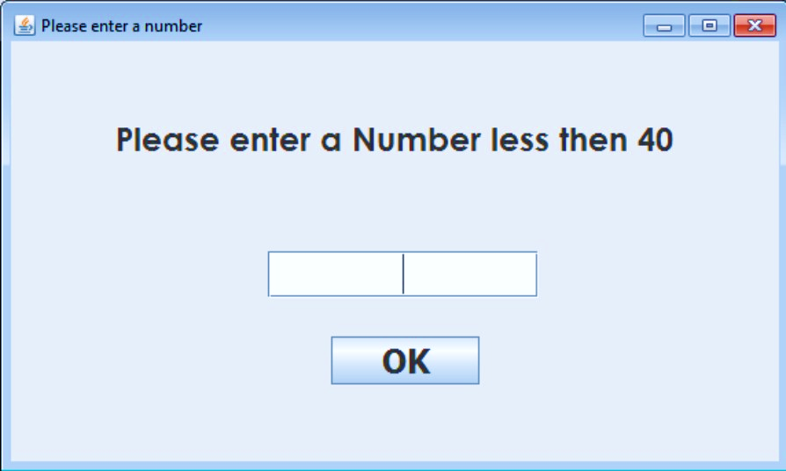**FRAME 6 (ENTER NO.)**

CODING:

package legionnaire_os;

import javax.swing.JOptionPane;

/* @author Mandeep M. Dalavi */

public class Enter_no extends javax.swing.JFrame {

int wordcount = 1;

public Enter_no() {

initComponents();

}

-----------------------------------------------------------------------------------------------------------

private void jButton1ActionPerformed(java.awt.event.ActionEvent evt) {

try {

int num = Integer.parseInt(numTF.getText());

if (num > 40)

{

JOptionPane.showMessageDialog(this, "Please enter a number less than 40", "Wrong Input", JOptionPane.WARNING_MESSAGE);

numTF.setText("");

}

else {

wordcount = num;

this.setVisible(false);

numTF.setText("");

}

}

catch (NumberFormatException e) {

JOptionPane.showMessageDialog(this, "Your input is invalid.", "Invalid Input", JOptionPane.ERROR_MESSAGE);

} }

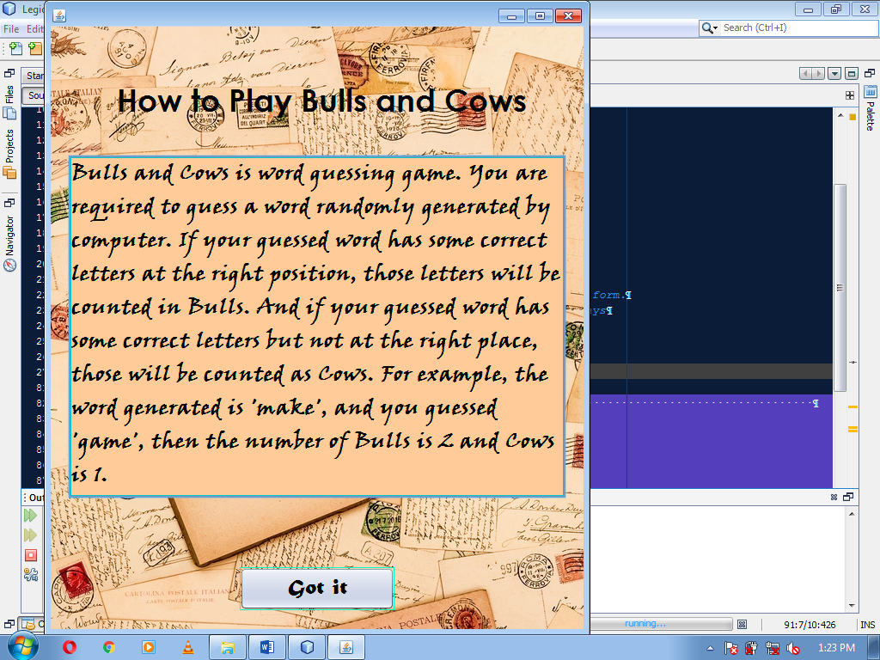**FRAME 7 (HOW TO PLAY)**

CODING:

package legionnaire_os;

/* @author Mandeep M. Dalavi */

public class How_to_Play extends javax.swing.JFrame {

public How_to_Play() {

initComponents();

}

-----------------------------------------------------------------------------------------------------------

private void formWindowActivated(java.awt.event.WindowEvent evt) {

this.setResizable(true);

this.setSize(636, 740);

}

-----------------------------------------------------------------------------------------------------------

private void GotitActionPerformed(java.awt.event.ActionEvent evt) {

this.setVisible(false);

}

-----------------------------------------------------------------------------------------------------------

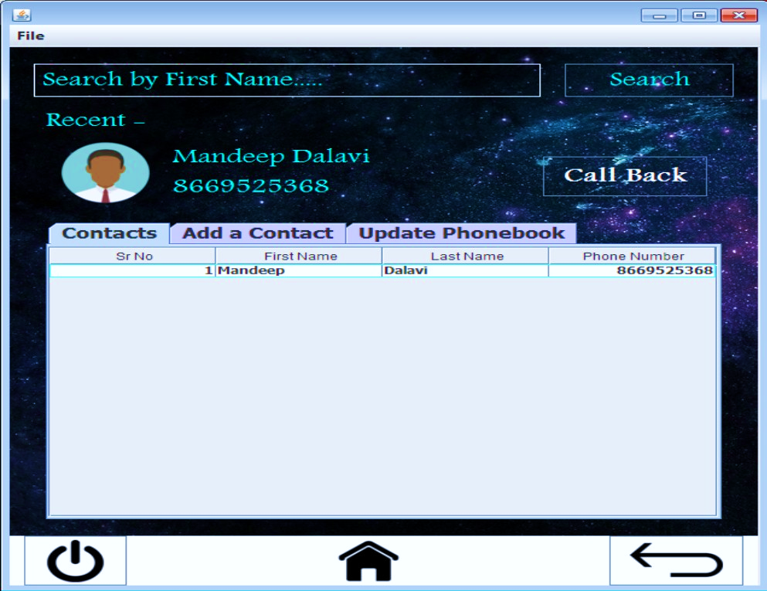**FRAME 8 (CONTACTS APP)**

CODING:

package legionnaire_os;

/* @author Mandeep M. Dalavi */

import java.sql.*;

import java.math.BigInteger;

import javax.swing.JOptionPane;

import javax.swing.table.DefaultTableModel;

public class Contacts_App extends javax.swing.JFrame {

public Contacts_App() {

initComponents();

//--------------------------------Contacts display in table--------------------------------//

DefaultTableModel model = (DefaultTableModel)

Contacttable.getModel();

try {

Class.forName("java.sql.DriverManager");

Connection con = (Connection) DriverManager.getConnection("jdbc:mysql://localhost:3306/legionnaire","root", "admin");

Statement stmt = (Statement) con.createStatement();

String query="SELECT * FROM contacts;";

ResultSet rs = stmt.executeQuery(query);

while(rs.next()) {

String SrNo = rs.getString("Sr_No");

String FirstName = rs.getString("First_Name");

String LastName = rs.getString("Last_Name");

String Number = rs.getString("Number");

model.addRow (new Object[] {SrNo, FirstName, LastName,Number});

}

}

catch (Exception e) {

JOptionPane.showMessageDialog (this, "Error in Connectivity!");

}

//--------------------------Name Display in Recent Called----------------------------//

try {

Class.forName("java.sql.Driver");

Connection con = (Connection) DriverManager.getConnection("jdbc:mysql://localhost:3306/legionnaire", "root", "admin");

Statement stmt = (Statement) con.createStatement();

String query = "SELECT * FROM calling";

ResultSet rs = stmt.executeQuery(query);

while (rs.next())

{

String Name = rs.getString(1);

String Number = rs.getString(2);

Contactname.setText(""+Name);

Contactnumber.setText("" +Number); }

con.close();

stmt.close();

rs.close();

}

catch (Exception e) {

JOptionPane.showMessageDialog(this, "Error in Connectivity!");

} }

-----------------------------------------------------------------------------------------------------------

private void BackbuttonActionPerformed(java.awt.event.ActionEvent evt) {

new Apps().setVisible(true);

this.setVisible(false);

}

private void AddcontactbuttonActionPerformed(java.awt.event.ActionEvent evt) {

String first = firsttext.getText();

String last = lasttext.getText();

BigInteger num = new BigInteger(numbertext.getText());

try {

Class.forName("java.sql.Driver");

Connection con = (Connection) DriverManager.getConnection("jdbc:mysql://localhost:3306/legionnaire", "root", "admin");

Statement stmt = (Statement) con.createStatement();

String query = "Select max(Sr_No) from contacts";

ResultSet rs1 = stmt.executeQuery(query);

rs1.next();

int srno = rs1.getInt(1) + 1;

String query2 = "Insert into contacts values(" + srno + ",'" + first + "','" + last + "'," + num + ")";

stmt.executeUpdate(query2);

JOptionPane.showMessageDialog(this, "Your Contact has been added successfully", "Contact Added", JOptionPane.INFORMATION_MESSAGE);

firsttext.setText("");

lasttext.setText("");

numbertext.setText("");

}

catch (Exception e) {

JOptionPane.showMessageDialog(this, “Error in Connectivity!”);

}

}

-----------------------------------------------------------------------------------------------------------

private void formWindowActivated(java.awt.event.WindowEvent evt) {

this.setResizable(true);

this.setSize(638, 715);

//Setting Buttons Invisible

first.setVisible(false);

last.setVisible(false);

number.setVisible(false);

firstTF.setVisible(false);

lastTF.setVisible(false);

numberTF.setVisible(false);

Deletebutton.setVisible(false);

Updatebutton.setVisible(false);

Resetbutton.setVisible(false);

}

-----------------------------------------------------------------------------------------------------------

private void PowerbuttonActionPerformed(java.awt.event.ActionEvent evt) {

if(JOptionPane.showConfirmDialog(this, "Are you sure you want to exit?", "Confirmation", JOptionPane.YES_NO_CANCEL_OPTION)==JOptionPane.YES_OPTION)

{

System.exit(0);

}

}

-----------------------------------------------------------------------------------------------------------

private void HomebuttonActionPerformed(java.awt.event.ActionEvent evt) {

new Home().setVisible(true);

this.setVisible(false);

}

-----------------------------------------------------------------------------------------------------------

private void JumpHomemenuActionPerformed(java.awt.event.ActionEvent evt) {

new Home().setVisible(true);

this.setVisible(false);

}

private void JumpAppmenuActionPerformed(java.awt.event.ActionEvent evt) {

new Apps().setVisible(true);

this.setVisible(false); }

-----------------------------------------------------------------------------------------------------------

private void ExitOSmenuActionPerformed(java.awt.event.ActionEvent evt) {

if(JOptionPane.showConfirmDialog(this, "Are you sure you want to exit?", "Confirmation", JOptionPane.YES_NO_CANCEL_OPTION)==JOptionPane.YES_OPTION)

{

System.exit(0);

} }

-----------------------------------------------------------------------------------------------------------

private void DeletebuttonActionPerformed(java.awt.event.ActionEvent evt) {

int SrNo = Integer.parseInt(Srenter.getText());

try {

Class.forName("java.sql.DriverManager");

Connection con = (Connection) DriverManager.getConnection("jdbc:mysql://localhost:3306/legionnaire","root", "admin");

Statement stmt = (Statement) con.createStatement();

String query="DELETE FROM Contacts where Sr_no = "+SrNo+";";

stmt.executeUpdate(query);

JOptionPane.showMessageDialog (this, "Contact Deleted Successfully.");

Srenter.setText("");

firstTF.setText("");

lastTF.setText("");

numberTF.setText("");

}

catch(Exception e) {

JOptionPane.showMessageDialog (this, "Error in Connectivity!");

} }

private void ShowdetailbuttonActionPerformed(java.awt.event.ActionEvent evt) {

String SrNo = Srenter.getText();

if(SrNo.isEmpty())

{

JOptionPane.showMessageDialog(this, "Please enter Serial Number");

}

else {

try {

Class.forName("java.sql.Driver");

Connection con = (Connection) DriverManager.getConnection("jdbc:mysql://localhost:3306/legionnaire", "root", "admin");

Statement stmt = (Statement) con.createStatement();

String query = "SELECT * FROM contacts where Sr_No = "+SrNo+";";

ResultSet rs = stmt.executeQuery(query);

while (rs.next()) {

String firstname = rs.getString(2);

String lastname = rs.getString(3);

String number = rs.getString(4);

firstTF.setText(""+firstname);

lastTF.setText("" +lastname);

numberTF.setText(""+number);

}

con.close();

stmt.close();

rs.close();

}

catch (Exception e) {

JOptionPane.showMessageDialog (this, "Error in Connectivity!");

} }

first.setVisible(true);

last.setVisible(true);

number.setVisible(true);

firstTF.setVisible(true);

lastTF.setVisible(true);

numberTF.setVisible(true);

Deletebutton.setVisible(true);

Updatebutton.setVisible(true);

Resetbutton.setVisible(true);

}

-----------------------------------------------------------------------------------------------------------

private void ResetbuttonActionPerformed(java.awt.event.ActionEvent evt) {

Srenter.setText("");

firstTF.setText("");

lastTF.setText("");

numberTF.setText("");

first.setVisible(false);

last.setVisible(false);

number.setVisible(false);

firstTF.setVisible(false);

lastTF.setVisible(false);

numberTF.setVisible(false);

Deletebutton.setVisible(false);

Updatebutton.setVisible(false);

Resetbutton.setVisible(false);

}

private void UpdatebuttonActionPerformed(java.awt.event.ActionEvent evt) {

String SrNo = Srenter.getText();

String First = firstTF.getText();

String Last = lastTF.getText();

String Number = numberTF.getText();

try {

Class.forName("java.sql.Driver");

Connection con = (Connection)

DriverManager.getConnection("jdbc:mysql://localhost:3306/legionnaire", "root", "admin");

Statement stmt = (Statement) con.createStatement();

String query = ("UPDATE Contacts SET First_Name ='"+First+"', Last_Name ='"+Last+"', Number = "+Number+" where Sr_No = "+SrNo+" ;");

ResultSet rs = stmt.executeQuery(query);

con.close();

stmt.close();

rs.close(); }

catch (Exception e) {

JOptionPane.showMessageDialog (this, "Error in Connectivity!");

}

//-----------------------------------------------------------------------------------------------------//

DefaultTableModel model = (DefaultTableModel)

Contacttable.getModel(); int rows=model.getRowCount();

if (rows>0)

{

for (int i=0; i<rows; i++)

model.removeRow(0);

}

try {

Class.forName("java.sql.DriverManager");

Connection con = (Connection)

DriverManager.getConnection("jdbc:mysql://localhost:3306/legionnaire","root", "admin");

Statement stmt = (Statement) con.createStatement();

String query="SELECT * FROM Contacts;";

ResultSet rs = stmt.executeQuery(query);

while(rs.next())

{

String Name = rs.getString("Name");

String Mobile = rs.getString("Mobile");

String Email = rs.getString("Email");

model.addRow (new Object[] {Name, Mobile,Email});

}

}

catch (Exception e) {

JOptionPane.showMessageDialog (this, “Error in Connectivity!”);

} }

-----------------------------------------------------------------------------------------------------------

private void SearchbuttonActionPerformed(java.awt.event.ActionEvent evt) {

String Search = Searchtext.getText();

try {

Class.forName("java.sql.DriverManager");

Connection con = (Connection) DriverManager.getConnection("jdbc:mysql://localhost:3306/legionnaire","root", "admin");

Statement stmt = (Statement) con.createStatement();

String query = "INSERT INTO Search VALUES('"+Search+"');";

stmt.executeUpdate(query);

new Contact_Details().setVisible(true);

this.setVisible(false);

}

catch(Exception e) {

JOptionPane.showMessageDialog (this, “Error in Connectivity!”);

}

}

-----------------------------------------------------------------------------------------------------------

private void SearchtextMouseClicked(java.awt.event.MouseEvent evt) {

Searchtext.setText("");

}

-----------------------------------------------------------------------------------------------------------

private void CallbackbuttonActionPerformed(java.awt.event.ActionEvent evt) {

JOptionPane.showMessageDialog(this, "Sorry You have no SIM card in phone. Please insert a SIM to call");

}

-----------------------------------------------------------------------------------------------------------

private void TabsMouseClicked(java.awt.event.MouseEvent evt) {

DefaultTableModel model = (DefaultTableModel)

Contacttable.getModel(); int rows=model.getRowCount();

if (rows>0)

{

for (int i=0; i<rows; i++)

model.removeRow(0);

}

//-----------------------------------------------------------------------------------------------------//

Contacttable.getModel();

try {

Class.forName("java.sql.DriverManager");

Connection con = (Connection) DriverManager.getConnection("jdbc:mysql://localhost:3306/legionnaire","root", "admin");

Statement stmt = (Statement) con.createStatement();

String query="SELECT * FROM contacts;";

ResultSet rs = stmt.executeQuery(query);

while(rs.next())

{

String SrNo = rs.getString("Sr_No");

String FirstName = rs.getString("First_Name");

String LastName = rs.getString("Last_Name");

String Number = rs.getString("Number");

model.addRow (new Object[] {SrNo, FirstName, LastName,Number});

}

}

catch (Exception e) {

JOptionPane.showMessageDialog (this, "Error in Connectivity!");

}

}

-----------------------------------------------------------------------------------------------------------

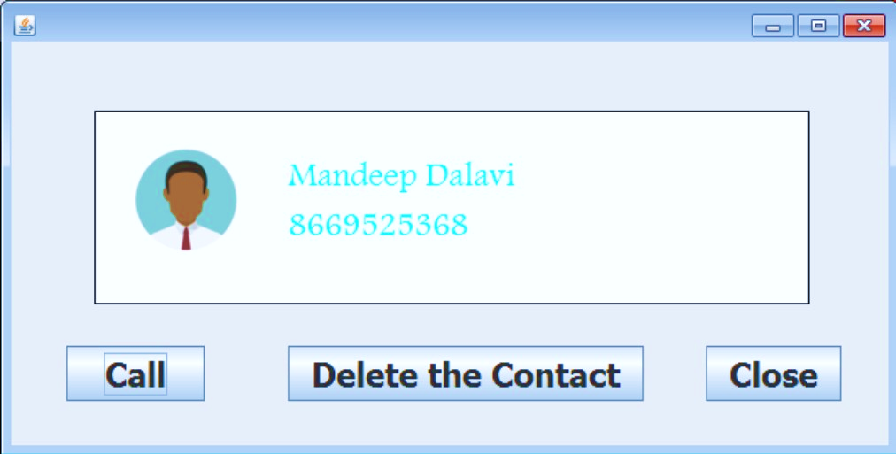**FRAME 9 (CONTACTS DETAILS)**

CODING:

package legionnaire_os;

import java.sql.*;;

import java.math.BigInteger;

import javax.swing.JOptionPane;

/* @author Mandeep M. Dalavi */

public class Contact_Details extends javax.swing.JFrame {

String firstname, lastname, number;

public Contact_Details() {

initComponents();

}

-----------------------------------------------------------------------------------------------------------

private void CloseActionPerformed(java.awt.event.ActionEvent evt) {

new Contacts_App().setVisible(true);

this.setVisible(false);

try {

Class.forName("java.sql.DriverManager");

Connection con = (Connection)

DriverManager.getConnection("jdbc:mysql://localhost:3306/legionnaire","root", "admin");

Statement stmt = (Statement) con.createStatement();

String query="DELETE from Search;";

stmt.executeUpdate(query);

}

catch(Exception e){

JOptionPane.showMessageDialog (this, “Error in Connectivity!”);

}

}

private void formWindowOpened(java.awt.event.WindowEvent evt) {

this.setSize(650, 330);

try {

Class.forName("java.sql.Driver");

Connection con = (Connection) DriverManager.getConnection("jdbc:mysql://localhost:3306/legionnaire", "root", "admin");

Statement stmt = (Statement) con.createStatement();

String query = "SELECT First_Name, Last_Name, Number FROM Contacts C, Search S where C.First_Name = S.Name;";

ResultSet rs = stmt.executeQuery(query);

while (rs.next())

{

firstname = rs.getString(1);

lastname = rs.getString(2);

number = rs.getString(3);

Contactname.setText(""+firstname+" "+lastname);

Contactnumber.setText(""+number);

}

con.close();

stmt.close();

rs.close();

}

catch (Exception e) {

JOptionPane.showMessageDialog (this, "Error in Connectivity!");

}

}

-----------------------------------------------------------------------------------------------------------

private void DeleteActionPerformed(java.awt.event.ActionEvent evt) {

number = Contactnumber.getText();

try {

Class.forName("java.sql.DriverManager");

Connection con = (Connection)

DriverManager.getConnection("jdbc:mysql://localhost:3306/legionnaire","root", "admin”);

Statement stmt = (Statement) con.createStatement();

String query="DELETE from Contacts where (First_Name = '"+firstname+"' && Number = "+number+");";

stmt.executeUpdate(query);

JOptionPane.showMessageDialog (this, "Contact Deleted Successfully.");

new Contacts_App().setVisible(true);

this.setVisible(false);

}

catch(Exception e) {

JOptionPane.showMessageDialog (this, “Error in Connectivity!”);

}

}

-----------------------------------------------------------------------------------------------------------

private void CallActionPerformed(java.awt.event.ActionEvent evt) {

String name = Contactname.getText();

BigInteger num = new BigInteger(Contactnumber.getText());

try {

Class.forName("java.sql.Driver");

Connection con = (Connection) DriverManager.getConnection("jdbc:mysql://localhost:3306/legionnaire", "root", "admin");

Statement stmt = (Statement) con.createStatement();

String query1 = "DELETE from calling";

int rs1 = stmt.executeUpdate(query1);

String query = "INSERT into calling VALUES('" + name + "'," + num + ")";

int rs = stmt.executeUpdate(query);

con.close();

stmt.close();

}

catch (Exception e) {

JOptionPane.showMessageDialog (this, "Error in connectivity!");

}

JOptionPane.showMessageDialog(null, "Sorry you have no SIM Card in phone. Please insert a SIM to call", "No SIM Card Detected", JOptionPane.ERROR_MESSAGE);

}

-----------------------------------------------------------------------------------------------------------

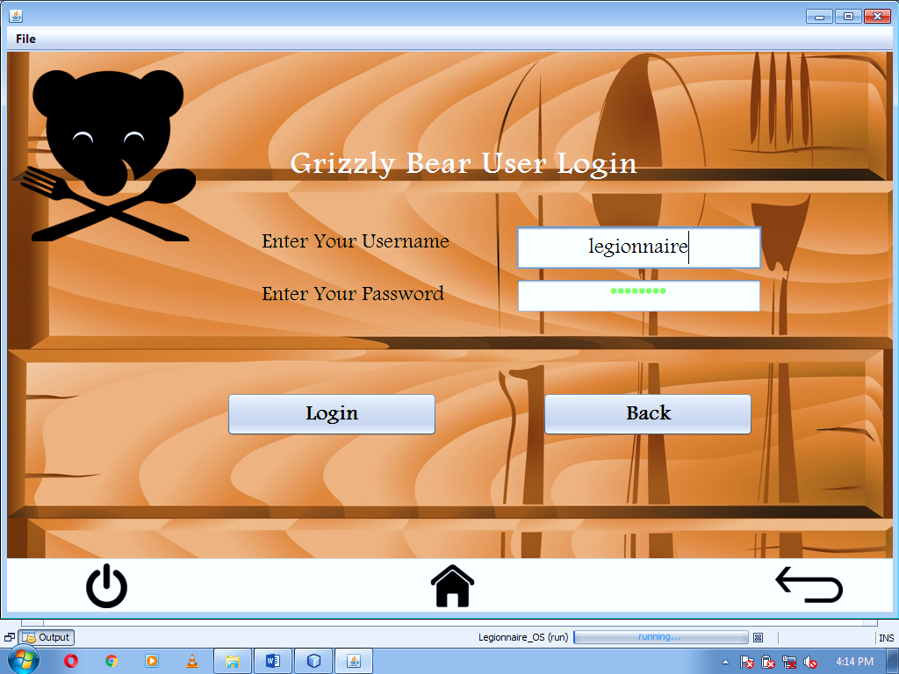**FRAME 10 (GRIZZLY BEAR LOGIN)**

CODING:

package legionnaire_os;

import java.sql.*;

import javax.swing.JOptionPane;

/* @author Mandeep M. Dalavi */

public class GrizzlyBear_Login extends javax.swing.JFrame {

String curusername;

String curpassword;

public GrizzlyBear_Login() {

initComponents();

//-------------------------JDBC part getting username and password----------------------//

try {

Class.forName("java.sql.Driver");

Connection con = (Connection) DriverManager.getConnection("jdbc:mysql://localhost:3306/legionnaire", "root", "admin");

Statement stmt = (Statement) con.createStatement();

String query = "Select * from userpass";

ResultSet rs = stmt.executeQuery(query);

if (rs.first())

{

curusername = rs.getString(1);

curpassword = rs.getString(2);

}

}

catch (Exception e) {

JOptionPane.showMessageDialog (this, “Error in Connectivity”);

}

private void Backbutton1ActionPerformed(java.awt.event.ActionEvent evt) {

new Apps().setVisible(true);

this.setVisible(false);

}

-----------------------------------------------------------------------------------------------------------

private void JumpHomemenuActionPerformed(java.awt.event.ActionEvent evt) {

new Home().setVisible(true);

this.setVisible(false);

}

-----------------------------------------------------------------------------------------------------------

private void JumpAppmenuActionPerformed(java.awt.event.ActionEvent evt) {

new Apps().setVisible(true);

this.setVisible(false);

}

-----------------------------------------------------------------------------------------------------------

private void ExitOSmenuActionPerformed(java.awt.event.ActionEvent evt) {

if(JOptionPane.showConfirmDialog(this, "Are you sure you want to exit?", "Confirmation", JOptionPane.YES_NO_CANCEL_OPTION)==JOptionPane.YES_OPTION)

{

System.exit(0);

}

}

-----------------------------------------------------------------------------------------------------------

private void formWindowActivated(java.awt.event.WindowEvent evt) {

this.setResizable(true);

this.setSize(1025, 706);

}

private void PowerbuttonActionPerformed(java.awt.event.ActionEvent evt) {

if(JOptionPane.showConfirmDialog(this, "Are you sure you want to exit?", "Confirmation", JOptionPane.YES_NO_CANCEL_OPTION)==JOptionPane.YES_OPTION)

{

System.exit(0);

}

}

-----------------------------------------------------------------------------------------------------------

private void HomebuttonActionPerformed(java.awt.event.ActionEvent evt) {

new Home().setVisible(true);

this.setVisible(false);

}

-----------------------------------------------------------------------------------------------------------

private void BackbuttonActionPerformed(java.awt.event.ActionEvent evt) {

new Apps().setVisible(true);

this.setVisible(false);

}

-----------------------------------------------------------------------------------------------------------

private void LoginbuttonActionPerformed(java.awt.event.ActionEvent evt) {

String user = Usernametext.getText();

String pass = new String(Password.getPassword());

if (user.equalsIgnoreCase(curusername) && pass.equalsIgnoreCase(curpassword))

{

JOptionPane.showMessageDialog(this,"You have been successfully logged in." );

new GrizzlyBear_Menu().setVisible(true);

this.dispose();

}

else

{

JOptionPane.showMessageDialog(this, "Password and User ID do not match. Please try again.", "Incorrect username or password", JOptionPane.ERROR_MESSAGE);

}

}

-----------------------------------------------------------------------------------------------------------

private void PasswordMouseClicked(java.awt.event.MouseEvent evt) {

Password.setText("");

}

-----------------------------------------------------------------------------------------------------------

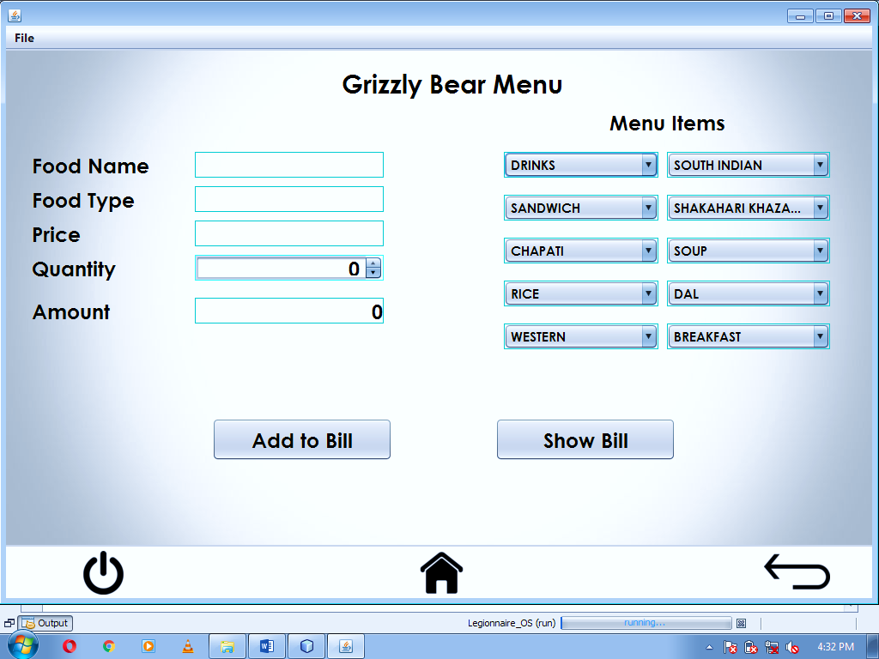**FRAME 11 (GRIZZLY BEAR MENU)**

CODING:

package legionnaire_os;

import java.sql.*;

import javax.swing.JOptionPane;

/* @author Mandeep M. Dalavi */

public class GrizzlyBear_Menu extends javax.swing.JFrame {

public GrizzlyBear_Menu() {

initComponents(); }

-----------------------------------------------------------------------------------------------------------

private void BackbuttonActionPerformed(java.awt.event.ActionEvent evt) {

new GrizzlyBear_Login().setVisible(true);

this.setVisible(false);

}

-----------------------------------------------------------------------------------------------------------

private void JumpHomemenuActionPerformed(java.awt.event.ActionEvent evt) {

new Home().setVisible(true);

this.setVisible(false);

}

-----------------------------------------------------------------------------------------------------------

private void JumpAppmenuActionPerformed(java.awt.event.ActionEvent evt) {

new Apps().setVisible(true);

this.setVisible(false); }

-----------------------------------------------------------------------------------------------------------

private void ExitOSmenuActionPerformed(java.awt.event.ActionEvent evt) {

if(JOptionPane.showConfirmDialog(this, "Are you sure you want to exit?", "Confirmation", JOptionPane.YES_NO_CANCEL_OPTION)==JOptionPane.YES_OPTION)

{ System.exit(0); }

}

private void formWindowActivated(java.awt.event.WindowEvent evt) {

this.setResizable(true);

this.setSize(1025, 705);

}

-----------------------------------------------------------------------------------------------------------

private void PowerbuttonActionPerformed(java.awt.event.ActionEvent evt) {

if(JOptionPane.showConfirmDialog(this, "Are you sure you want to exit?", "Confirmation", JOptionPane.YES_NO_CANCEL_OPTION)==JOptionPane.YES_OPTION)

{

System.exit(0);

}

}

-----------------------------------------------------------------------------------------------------------

private void HomebuttonActionPerformed(java.awt.event.ActionEvent evt) {

new Home().setVisible(true);

this.setVisible(false);

}

-----------------------------------------------------------------------------------------------------------

private void ShowBillbuttonActionPerformed(java.awt.event.ActionEvent evt) {

new GrizzlyBear_Bill().setVisible(true);

this.setVisible(false);

}

-----------------------------------------------------------------------------------------------------------

private void AddBillbuttonActionPerformed(java.awt.event.ActionEvent evt) {

String Food = FoodName.getText();

int price = Integer.parseInt(Price.getText());

int quantity = (int) Quantity.getValue();

int total = Integer.parseInt(Amount.getText());

try {

Class.forName("java.sql.DriverManager");

Connection con = (Connection)

DriverManager.getConnection("jdbc:mysql://localhost:3306/legionnaire","root", "admin");

Statement stmt = (Statement) con.createStatement();

String query="INSERT INTO BILL VALUES('"+Food+"', "+price+", "+quantity+", "+total+");";

stmt.executeUpdate(query);

}

catch(Exception e) {

JOptionPane.showMessageDialog(this, “Error in Connectivity!”);

}

}

-----------------------------------------------------------------------------------------------------------

private void DrinksItemStateChanged(java.awt.event.ItemEvent evt) {

int food = Drinks.getSelectedIndex();

switch (food) {

case 1:

FoodName.setText("");

FoodType.setText("");

Price.setText("");

FoodName.setText("Tea");

FoodType.setText("Drinks");

Price.setText("" + 20);

break;

case 2:

FoodName.setText("");

FoodType.setText("");

Price.setText("");

FoodName.setText("Coffee");

FoodType.setText("Drinks");

Price.setText("" + 25);

break;

case 3:

FoodName.setText("");

FoodType.setText("");

Price.setText("");

FoodName.setText("Soda");

FoodType.setText("Drinks");

Price.setText("" + 15);

break;

case 4:

FoodName.setText("");

FoodType.setText("");

Price.setText("");

FoodName.setText("Soft Drink");

FoodType.setText("Drinks");

Price.setText("" + 35);

break;

case 5:

FoodName.setText("");

FoodType.setText("");

Price.setText("");

FoodName.setText("Lime Soda");

FoodType.setText("Drinks");

Price.setText("" + 25);

break;

case 6:

FoodName.setText("");

FoodType.setText("");

Price.setText("");

FoodName.setText("Milk Shake");

FoodType.setText("Drinks");

Price.setText("" + 40);

break;

case 7:

FoodName.setText("");

FoodType.setText("");

Price.setText("");

FoodName.setText("Vanilla Shake");

FoodType.setText("Drinks");

Price.setText("" + 60);

break;

case 8:

FoodName.setText("");

FoodType.setText("");

Price.setText("");

FoodName.setText("Chocolate Shake");

FoodType.setText("Drinks");

Price.setText("" + 80);

break;

case 9:

FoodName.setText("");

FoodType.setText("");

Price.setText("");

FoodName.setText("Strawberry Shake");

FoodType.setText("Drinks");

Price.setText("" + 60);

break;

default:

break;

}

Quantity.setValue(0);

Amount.setText("");

}

-----------------------------------------------------------------------------------------------------------

private void SouthIndianItemStateChanged(java.awt.event.ItemEvent evt) {

int food = SouthIndian.getSelectedIndex();

switch (food) {

case 1:

FoodName.setText("");

FoodType.setText("");

Price.setText("");

FoodName.setText("Sada Dosa");

FoodType.setText("South Indian");

Price.setText("" + 50);

break;

case 2:

FoodName.setText("");

FoodType.setText("");

Price.setText("");

FoodName.setText("Masala Dosa");

FoodType.setText("South Indian");

Price.setText("" + 60);

break;

case 3:

FoodName.setText("");

FoodType.setText("");

Price.setText("");

FoodName.setText("Uttapam");

FoodType.setText("South Indian");

Price.setText("" + 55);

break;

case 4:

FoodName.setText("");

FoodType.setText("");

Price.setText("");

FoodName.setText("Rava Dosa");

FoodType.setText("South Indian");

Price.setText("" + 55);

break;

case 5:

FoodName.setText("");

FoodType.setText("");

Price.setText("");

FoodName.setText("Rava Masala");

FoodType.setText("South Indian");

Price.setText("" + 65);

break;

case 6:

FoodName.setText("");

FoodType.setText("");

Price.setText("");

FoodName.setText("Spring Masala");

FoodType.setText("South Indian");

Price.setText("" + 75);

break;

default:

break;

}

Quantity.setValue(0);

Amount.setText("");

}

-----------------------------------------------------------------------------------------------------------

private void SandwichItemStateChanged(java.awt.event.ItemEvent evt) {

int food = Sandwich.getSelectedIndex();

switch (food) {

case 1:

FoodName.setText("");

FoodType.setText("");

Price.setText("");

FoodName.setText("Veg Sandwich");

FoodType.setText("Sandwich");

Price.setText("" + 40);

break;

case 2:

FoodName.setText("");

FoodType.setText("");

Price.setText("");

FoodName.setText("Chatni Sandwich");

FoodType.setText("Sandwich");

Price.setText("" + 30);

break;

case 3:

FoodName.setText("");

FoodType.setText("");

Price.setText("");

FoodName.setText("Omlet Sandwich");

FoodType.setText("Sandwich");

Price.setText("" + 55);

break;

case 4:

FoodName.setText("");

FoodType.setText("");

Price.setText("");

FoodName.setText("Cheese Sandwich");

FoodType.setText("Sandwich");

Price.setText("" + 70);

break;

case 5:

FoodName.setText("");

FoodType.setText("");

Price.setText("");

FoodName.setText("Club Sandwich");

FoodType.setText("Sandwich");

Price.setText("" + 80);

break;

case 6:

FoodName.setText("");

FoodType.setText("");

Price.setText("");

FoodName.setText("Veg Grill Sandwich");

FoodType.setText("Sandwich");

Price.setText("" + 65);

break;

case 7:

FoodName.setText("");

FoodType.setText("");

Price.setText("");

FoodName.setText("Diamond Club Sandwich");

FoodType.setText("Sandwich");

Price.setText("" + 100);

break;

default:

break;

}

Quantity.setValue(0);

Amount.setText("");

}

-----------------------------------------------------------------------------------------------------------

private void ShakahariKhazanaItemStateChanged(java.awt.event.ItemEvent evt) {

int food = ShakahariKhazana.getSelectedIndex();

switch (food) {

case 1:

FoodName.setText("");

FoodType.setText("");

Price.setText("");

FoodName.setText("Veg Handi");

FoodType.setText("Shakahari Khazana");

Price.setText("" + 145);

break;

case 2:

FoodName.setText("");

FoodType.setText("");

Price.setText("");

FoodName.setText("Mix Vegetables");

FoodType.setText("Shakahari Khazana");

Price.setText("" + 120);

break;

case 3:

FoodName.setText("");

FoodType.setText("");

Price.setText("");

FoodName.setText("Dum Allu");

FoodType.setText("Shakahari Khazana");

Price.setText("" + 135);

break;

case 4:

FoodName.setText("");

FoodType.setText("");

Price.setText("");

FoodName.setText("Allu Mutter");

FoodType.setText("Shakahari Khazana");

Price.setText("" + 105);

break;

case 5:

FoodName.setText("");

FoodType.setText("");

Price.setText("");

FoodName.setText("Chhole Bhature");

FoodType.setText("Shakahari Khazana");

Price.setText("" + 140);

break;

case 6:

FoodName.setText("");

FoodType.setText("");

Price.setText("");

FoodName.setText("Mutter Paneer");

FoodType.setText("Shakahari Khazana");

Price.setText("" + 145);

break;

case 7:

FoodName.setText("");

FoodType.setText("");

Price.setText("");

FoodName.setText("Paneer Tikka");

FoodType.setText("Shakahari Khazana");

Price.setText("" + 160);

break;

case 8:

FoodName.setText("");

FoodType.setText("");

Price.setText("");

FoodName.setText("Kaju Masala");

FoodType.setText("Shakahari Khazana");

Price.setText("" + 185);

break;

case 9:

FoodName.setText("");

FoodType.setText("");

Price.setText("");

FoodName.setText("Mushroom Fry");

FoodType.setText("Shakahari Khazana");

Price.setText("" + 145);

break;

default:

break;

}

Quantity.setValue(0);

Amount.setText("");

}

-----------------------------------------------------------------------------------------------------------

private void ChapatiItemStateChanged(java.awt.event.ItemEvent evt) {

int food = Chapati.getSelectedIndex();

switch (food) {

case 1:

FoodName.setText("");

FoodType.setText("");

Price.setText("");

FoodName.setText("Chapati");

FoodType.setText("Chapati");

Price.setText("" + 8);

break;

case 2:

FoodName.setText("");

FoodType.setText("");

Price.setText("");

FoodName.setText("Roti");

FoodType.setText("Chapati");

Price.setText("" + 15);

break;

case 3:

FoodName.setText("");

FoodType.setText("");

Price.setText("");

FoodName.setText("Paratha");

FoodType.setText("Chapati");

Price.setText("" + 24);

break;

case 4:

FoodName.setText("");

FoodType.setText("");

Price.setText("");

FoodName.setText("Naan");

FoodType.setText("Chapati");

Price.setText("" + 25);

break;

case 5:

FoodName.setText("");

FoodType.setText("");

Price.setText("");

FoodName.setText("Garlic Naan");

FoodType.setText("Chapati");

Price.setText("" + 50);

break;

case 6:

FoodName.setText("");

FoodType.setText("");

Price.setText("");

FoodName.setText("Kashmiri Naan");

FoodType.setText("Chapati");

Price.setText("" + 50);

break;

default:

break;

}

Quantity.setValue(0);

Amount.setText("");

}

-----------------------------------------------------------------------------------------------------------

private void SoupItemStateChanged(java.awt.event.ItemEvent evt) {

int food = Soup.getSelectedIndex();

switch (food) {

case 1:

FoodName.setText("");

FoodType.setText("");

Price.setText("");

FoodName.setText("Tomato Soup");

FoodType.setText("Soup");

Price.setText("" + 85);

break;

case 2:

FoodName.setText("");

FoodType.setText("");

Price.setText("");

FoodName.setText("Veg Manchow");

FoodType.setText("Soup");

Price.setText("" + 95);

break;

case 3:

FoodName.setText("");

FoodType.setText("");

Price.setText("");

FoodName.setText("Veg Noddles");

FoodType.setText("Soup");

Price.setText("" + 90);

break;

case 4:

FoodName.setText("");

FoodType.setText("");

Price.setText("");

FoodName.setText("Palak Soup");

FoodType.setText("Soup");

Price.setText("" + 90);

break;

case 5:

FoodName.setText("");

FoodType.setText("");

Price.setText("");

FoodName.setText("Sweet Corn Noddles");

FoodType.setText("Soup");

Price.setText("" + 90);

break;

default:

break;

}

Quantity.setValue(0);

Amount.setText("");

}

-----------------------------------------------------------------------------------------------------------

private void RiceItemStateChanged(java.awt.event.ItemEvent evt) {

int food = Rice.getSelectedIndex();

switch (food) {

case 1:

FoodName.setText("");

FoodType.setText("");

Price.setText("");

FoodName.setText("Plain Rice");

FoodType.setText("Rice");

Price.setText("" + 90);

break;

case 2:

FoodName.setText("");

FoodType.setText("");

Price.setText("");

FoodName.setText("Jeera Rice");

FoodType.setText("Rice");

Price.setText("" + 100);

break;

case 3:

FoodName.setText("");

FoodType.setText("");

Price.setText("");

FoodName.setText("Lemon Rice");

FoodType.setText("Rice");

Price.setText("" + 100);

break;

case 4:

FoodName.setText("");

FoodType.setText("");

Price.setText("");

FoodName.setText("Veg Fried Rice");

FoodType.setText("Rice");

Price.setText("" + 120);

break;

case 5:

FoodName.setText("");

FoodType.setText("");

Price.setText("");

FoodName.setText("Jeera Fried Rice");

FoodType.setText("Rice");

Price.setText("" + 120);

break;

default:

break;

}

Quantity.setValue(0);

Amount.setText("");

}

-----------------------------------------------------------------------------------------------------------

private void DalItemStateChanged(java.awt.event.ItemEvent evt) {

int food = Dal.getSelectedIndex();

switch (food) {

case 1:

FoodName.setText("");

FoodType.setText("");

Price.setText("");

FoodName.setText("Dal Fry");

FoodType.setText("Dal");

Price.setText("" + 95);

break;

case 2:

FoodName.setText("");

FoodType.setText("");

Price.setText("");

FoodName.setText("Dal Tadka");

FoodType.setText("Dal");

Price.setText("" + 110);

break;

case 3:

FoodName.setText("");

FoodType.setText("");

Price.setText("");

FoodName.setText("Dal Makhani");

FoodType.setText("Dal");

Price.setText("" + 110);

break;

case 4:

FoodName.setText("");

FoodType.setText("");

Price.setText("");

FoodName.setText("Dal Palak");

FoodType.setText("Dal");

Price.setText("" + 120);

break;

case 5:

FoodName.setText("");

FoodType.setText("");

Price.setText("");

FoodName.setText("Dal Moghlai");

FoodType.setText("Dal");

Price.setText("" + 120);

break;

default:

break;

}

Quantity.setValue(0);

Amount.setText("");

}

-----------------------------------------------------------------------------------------------------------

private void WesternItemStateChanged(java.awt.event.ItemEvent evt) {

int food = Western.getSelectedIndex();

switch (food) {

case 1:

FoodName.setText("");

FoodType.setText("");

Price.setText("");

FoodName.setText("Pandi with Pita");

FoodType.setText("Western");

Price.setText("" + 350);

break;

case 2:

FoodName.setText("");

FoodType.setText("");

Price.setText("");

FoodName.setText("Naga Pork Curry");

FoodType.setText("Western");

Price.setText("" + 390);

break;

case 3:

FoodName.setText("");

FoodType.setText("");

Price.setText("");

FoodName.setText("Mushroom Crepes");

FoodType.setText("Western");

Price.setText("" + 350);

break;

case 4:

FoodName.setText("");

FoodType.setText("");

Price.setText("");

FoodName.setText("Champagne Risotto");

FoodType.setText("Western");

Price.setText("" + 360);

break;

case 5:

FoodName.setText("");

FoodType.setText("");

Price.setText("");

FoodName.setText("Peri-Peri Grilled Chicken");

FoodType.setText("Western");

Price.setText("" + 390);

break;

case 6:

FoodName.setText("");

FoodType.setText("");

Price.setText("");

FoodName.setText("Lamb Chops with Beer Sauce");

FoodType.setText("Western");

Price.setText("" + 500);

break;

default:

break;

}

Quantity.setValue(0);

Amount.setText("");

}

-----------------------------------------------------------------------------------------------------------

private void BreakfastItemStateChanged(java.awt.event.ItemEvent evt) {

int food = Breakfast.getSelectedIndex();

switch (food) {

case 1:

FoodName.setText("");

FoodType.setText("");

Price.setText("");

FoodName.setText("Maharaja Mac");

FoodType.setText("Breakfast");

Price.setText("" + 159);

break;

case 2:

FoodName.setText("");

FoodType.setText("");

Price.setText("");

FoodName.setText("Fries");

FoodType.setText("Breakfast");

Price.setText("" + 50);

break;

case 3:

FoodName.setText("");

FoodType.setText("");

Price.setText("");

FoodName.setText("Happy Meal");

FoodType.setText("Breakfast");

Price.setText("" + 46);

break;

case 4:

FoodName.setText("");

FoodType.setText("");

Price.setText("");

FoodName.setText("Fruit 'N Yogurt Partait");

FoodType.setText("Breakfast");

Price.setText("" + 90);

break;

case 5:

FoodName.setText("");

FoodType.setText("");

Price.setText("");

FoodName.setText("Maxican Green Wave");

FoodType.setText("Breakfast");

Price.setText("" + 385);

break;

case 6:

FoodName.setText("");

FoodType.setText("");

Price.setText("");

FoodName.setText("Veg Extravaganza");

FoodType.setText("Breakfast");

Price.setText("" + 450);

break;

case 7:

FoodName.setText("");

FoodType.setText("");

Price.setText("");

FoodName.setText("Veggie Paradise");

FoodType.setText("Breakfast");

Price.setText("" + 385);

break;

default:

break;

}

Quantity.setValue(0);

Amount.setText("");

}

-----------------------------------------------------------------------------------------------------------

private void QuantityStateChanged(javax.swing.event.ChangeEvent evt) {

int price = Integer.parseInt(Price.getText());

int quantity = (int) Quantity.getValue();

int b = price*quantity;

Amount.setText(""+b);

}

-----------------------------------------------------------------------------------------------------------

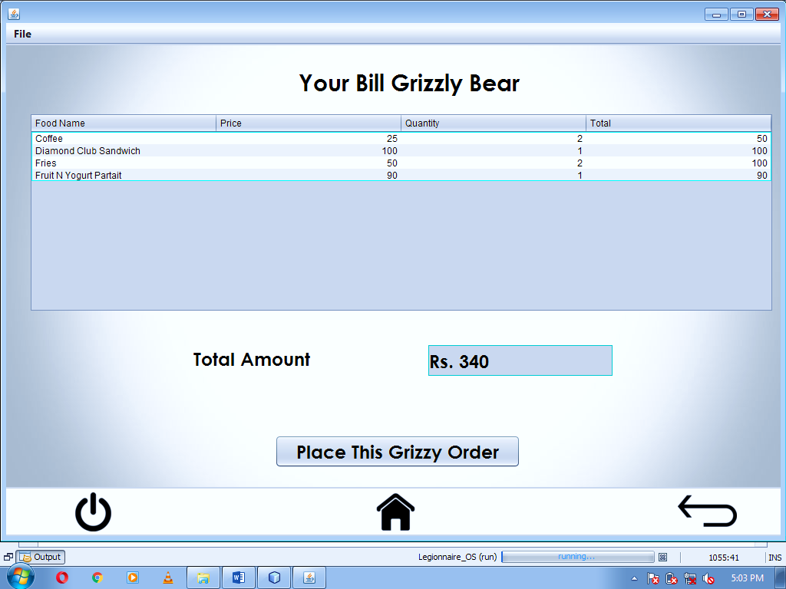**FRAME 12 (GRIZZLY BEAR BILL)**

CODING:

package legionnaire_os;

import java.sql.*;

import javax.swing.JOptionPane;

import javax.swing.table.DefaultTableModel;

/* @author Mandeep M. Dalavi */

public class GrizzlyBear_Bill extends javax.swing.JFrame {

public GrizzlyBear_Bill() {

initComponents();

//--------------------------JDBC displaying Bill---------------------------//

DefaultTableModel model = (DefaultTableModel)

BillTable.getModel();

try {

Class.forName("java.sql.DriverManager");

Connection con = (Connection)

DriverManager.getConnection("jdbc:mysql://localhost:3306/legionnaire","root", "admin");

Statement stmt = (Statement) con.createStatement();

String query="SELECT*from Bill;";

ResultSet rs = stmt.executeQuery(query);

while(rs.next())

{

String foodname = rs.getString(1);

String price = rs.getString(2);

String quantity = rs.getString(3);

String total = rs.getString(4);

model.addRow (new Object[] {foodname, price, quantity, total});

}

String query1 = "SELECT sum(total) from Bill";

ResultSet RS = stmt.executeQuery(query1);

while(RS.next())

{

String sum = RS.getString(1);

TotalAmount.setText("Rs. "+sum);

}

}

catch (Exception e) {

JOptionPane.showMessageDialog(this, "Error in Connectivity!");

}

}

-----------------------------------------------------------------------------------------------------------

private void BackbuttonActionPerformed(java.awt.event.ActionEvent evt) {

new GrizzlyBear_Menu().setVisible(true);

this.setVisible(false);

}

-----------------------------------------------------------------------------------------------------------

private void JumpHomemenuActionPerformed(java.awt.event.ActionEvent evt) {

new Home().setVisible(true);

this.setVisible(false);

}

-----------------------------------------------------------------------------------------------------------

private void JumpAppmenuActionPerformed(java.awt.event.ActionEvent evt) {

new Apps().setVisible(true);

this.setVisible(false);

}

-----------------------------------------------------------------------------------------------------------

private void ExitOSmenuActionPerformed(java.awt.event.ActionEvent evt) {

if(JOptionPane.showConfirmDialog(this, "Are you sure you want to exit?", "Confirmation", JOptionPane.YES_NO_CANCEL_OPTION)==JOptionPane.YES_OPTION)

{

System.exit(0);

}

}

-----------------------------------------------------------------------------------------------------------

private void formWindowActivated(java.awt.event.WindowEvent evt) {

this.setResizable(true);

this.setSize(1025, 707);

}

-----------------------------------------------------------------------------------------------------------

private void HomebuttonActionPerformed(java.awt.event.ActionEvent evt) {

new Home().setVisible(true);

this.setVisible(false);

}

-----------------------------------------------------------------------------------------------------------

private void PowerbuttonActionPerformed(java.awt.event.ActionEvent evt) {

if(JOptionPane.showConfirmDialog(this, "Are you sure you want to exit?", "Confirmation", JOptionPane.YES_NO_CANCEL_OPTION)==JOptionPane.YES_OPTION)

{

System.exit(0);

}

}

-----------------------------------------------------------------------------------------------------------

private void PlaceOrderbuttonActionPerformed(java.awt.event.ActionEvent evt) {

DefaultTableModel model = (DefaultTableModel)

BillTable.getModel(); int rows=model.getRowCount();

if (rows>0)

{

for (int i=0; i<rows; i++)

model.removeRow(0);

}

try {

Class.forName("java.sql.DriverManager");

Connection con = (Connection)

DriverManager.getConnection("jdbc:mysql://localhost:3306/legionnaire","root", "admin");

Statement stmt = (Statement) con.createStatement();

String query="DELETE from Bill;";

stmt.executeUpdate(query);

}

catch(Exception e) {

JOptionPane.showMessageDialog (this, “Error in Connectivity!”);

}

JOptionPane.showMessageDialog(this, "Your Order has been place."+'\n'+"Order will be Delivered in 20-30min"+'\n'+"Please give the Total Amount to the Delivery Man."+'\n'+"Thank You for using Grizzy Bear"+'\n'+"Please give feedbacks");

}

-----------------------------------------------------------------------------------------------------------

**FRAME 13 (CALCULATOR APP)**

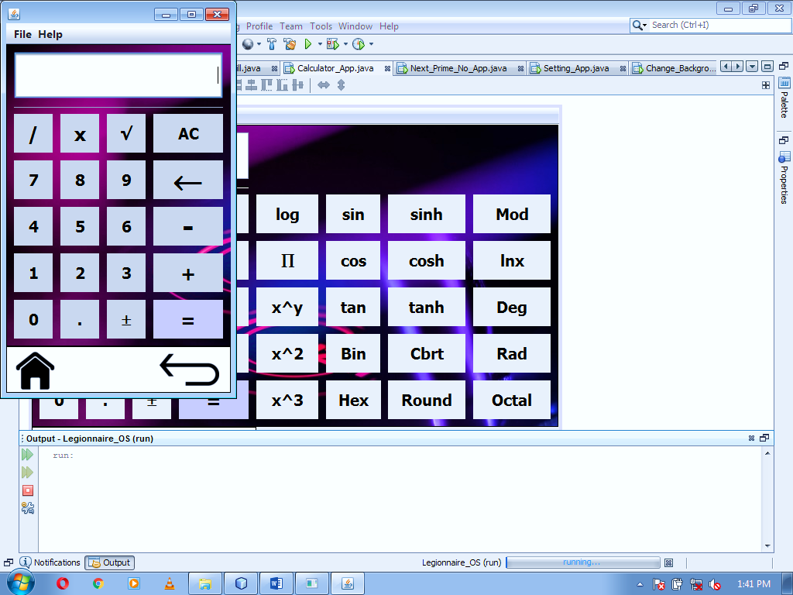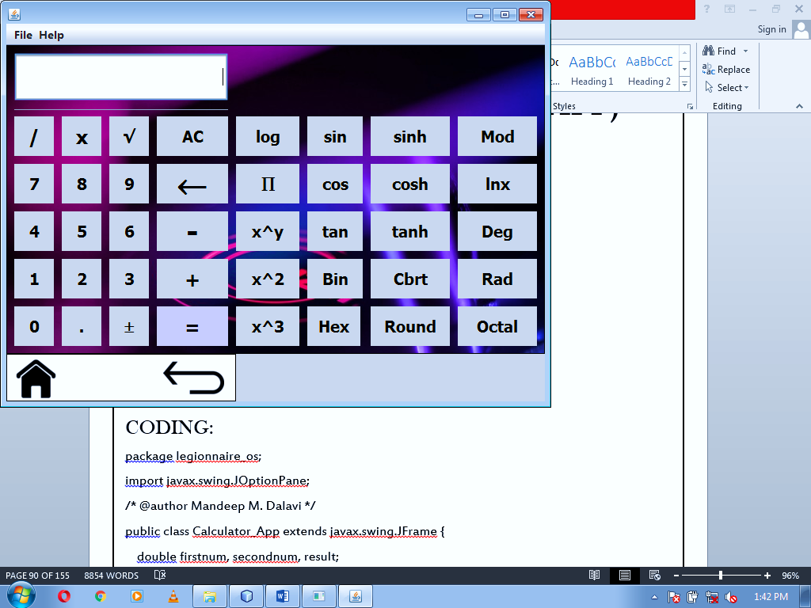

CODING:

package legionnaire_os;

import javax.swing.JOptionPane;

/* @author Mandeep M. Dalavi */

public class Calculator_App extends javax.swing.JFrame {

double firstnum, secondnum, result;

String operations;

private Object math;

public Calculator_App() {

initComponents();

}

-----------------------------------------------------------------------------------------------------------

private void BackbuttonActionPerformed(java.awt.event.ActionEvent evt) {

new Apps().setVisible(true);

this.setVisible(false);

}

-----------------------------------------------------------------------------------------------------------

private void DividebuttonActionPerformed(java.awt.event.ActionEvent evt) {

firstnum = Double.parseDouble(input.getText());

input.setText(null);

operations=("/");

}

-----------------------------------------------------------------------------------------------------------

private void formWindowActivated(java.awt.event.WindowEvent evt) {

this.setResizable(true);

this.setSize(306, 515);

}

-----------------------------------------------------------------------------------------------------------

private void StandardActionPerformed(java.awt.event.ActionEvent evt) {

this.setResizable(true);

this.setSize(306, 515);

input.setSize(270, 60);

Separator.setSize(270, 5);

Powerpanel.setSize(290, 60);

input.setSize(270, 60);

}

-----------------------------------------------------------------------------------------------------------

private void ScientificActionPerformed(java.awt.event.ActionEvent evt) {

this.setResizable(true);

this.setSize(696, 515);

input.setSize(660, 60);

Separator.setSize(660, 5);

Powerpanel.setSize(680, 60);

input.setSize(660, 60);

}

-----------------------------------------------------------------------------------------------------------

private void SevenbuttonActionPerformed(java.awt.event.ActionEvent evt) {

String iNum = input.getText()+Sevenbutton.getText();

input.setText(iNum);

}

-----------------------------------------------------------------------------------------------------------

private void EightbuttonActionPerformed(java.awt.event.ActionEvent evt) {

String iNum = input.getText()+Eightbutton.getText();

input.setText(iNum);

}

private void NinebuttonActionPerformed(java.awt.event.ActionEvent evt) {

String iNum = input.getText()+Ninebutton.getText();

input.setText(iNum);

}

-----------------------------------------------------------------------------------------------------------

private void FourbuttonActionPerformed(java.awt.event.ActionEvent evt) {

String iNum = input.getText()+Fourbutton.getText();

input.setText(iNum);

}

-----------------------------------------------------------------------------------------------------------

private void FivebuttonActionPerformed(java.awt.event.ActionEvent evt) {

String iNum = input.getText()+Fivebutton.getText();

input.setText(iNum);

}

-----------------------------------------------------------------------------------------------------------

private void SixbuttonActionPerformed(java.awt.event.ActionEvent evt) {

String iNum = input.getText()+Sixbutton.getText();

input.setText(iNum);

}

-----------------------------------------------------------------------------------------------------------

private void OnebuttonActionPerformed(java.awt.event.ActionEvent evt) {

String iNum = input.getText()+Onebutton.getText();

input.setText(iNum);

}

-----------------------------------------------------------------------------------------------------------

private void TwobuttonActionPerformed(java.awt.event.ActionEvent evt) {

String iNum = input.getText()+Twobutton.getText();

input.setText(iNum); }

private void ThreebuttonActionPerformed(java.awt.event.ActionEvent evt) {

String iNum = input.getText()+Threebutton.getText();

input.setText(iNum);

}

-----------------------------------------------------------------------------------------------------------

private void DeletebuttonActionPerformed(java.awt.event.ActionEvent evt) {

String backspace = null;

if(input.getText().length() > 0)

{

StringBuilder strB = new StringBuilder(input.getText());

strB.deleteCharAt(input.getText().length()-1);

backspace = strB.toString();

input.setText(backspace);

}

}

-----------------------------------------------------------------------------------------------------------

private void ZerobuttonActionPerformed(java.awt.event.ActionEvent evt) {

String iNum = input.getText()+Zerobutton.getText();

input.setText(iNum);

}

-----------------------------------------------------------------------------------------------------------

private void DotButtonActionPerformed(java.awt.event.ActionEvent evt) {

if(!input.getText().contains("."))

{

input.setText(input.getText()+DotButton.getText());

}

}

private void PlusminusbuttonActionPerformed(java.awt.event.ActionEvent evt) {

double A = Double.parseDouble(String.valueOf(input.getText()));

A = A*(-1);

input.setText(String.valueOf(A));

}

-----------------------------------------------------------------------------------------------------------

private void SqrtbuttonActionPerformed(java.awt.event.ActionEvent evt) {

double A = Double.parseDouble(String.valueOf(input.getText()));

A = Math.sqrt(A);

input.setText(String.valueOf(A));

}

-----------------------------------------------------------------------------------------------------------

private void Logbutton1ActionPerformed(java.awt.event.ActionEvent evt) {

double A = Double.parseDouble(String.valueOf(input.getText()));

A = Math.log(A);

input.setText(String.valueOf(A));

}

-----------------------------------------------------------------------------------------------------------

private void SinbuttonActionPerformed(java.awt.event.ActionEvent evt) {

double A = Double.parseDouble(String.valueOf(input.getText()));

A = Math.sin(A);

input.setText(String.valueOf(A));

}

-----------------------------------------------------------------------------------------------------------

private void SinhbuttonActionPerformed(java.awt.event.ActionEvent evt) {

double A = Double.parseDouble(String.valueOf(input.getText()));

A = Math.sinh(A);

input.setText(String.valueOf(A)); }

private void CbrbuttonActionPerformed(java.awt.event.ActionEvent evt) {

double A = Double.parseDouble(String.valueOf(input.getText()));

A = Math.cbrt(A);

input.setText(String.valueOf(A));

}

-----------------------------------------------------------------------------------------------------------

private void RoundbuttonActionPerformed(java.awt.event.ActionEvent evt) {

double A = Double.parseDouble(String.valueOf(input.getText()));

A = Math.round(A);

input.setText(String.valueOf(A));

}

-----------------------------------------------------------------------------------------------------------

private void CosbuttonActionPerformed(java.awt.event.ActionEvent evt) {

double A = Double.parseDouble(String.valueOf(input.getText()));

A = Math.cos(A);

input.setText(String.valueOf(A));

}

-----------------------------------------------------------------------------------------------------------

private void CoshbuttonActionPerformed(java.awt.event.ActionEvent evt) {

double A = Double.parseDouble(String.valueOf(input.getText()));

A = Math.cosh(A);

input.setText(String.valueOf(A));

}

-----------------------------------------------------------------------------------------------------------

private void TanbuttonActionPerformed(java.awt.event.ActionEvent evt) {

double A = Double.parseDouble(String.valueOf(input.getText()));

A = Math.tan(A);

input.setText(String.valueOf(A)); }

private void TanhbuttonActionPerformed(java.awt.event.ActionEvent evt) {

double A = Double.parseDouble(String.valueOf(input.getText()));

A = Math.tanh(A);

input.setText(String.valueOf(A));

}

-----------------------------------------------------------------------------------------------------------

private void xybuttonActionPerformed(java.awt.event.ActionEvent evt) {

double A = Double.parseDouble(String.valueOf(input.getText()));

A = Math.pow(A, A);

input.setText(String.valueOf(A));

}

-----------------------------------------------------------------------------------------------------------

private void x2buttonActionPerformed(java.awt.event.ActionEvent evt) {

double A = Double.parseDouble(String.valueOf(input.getText()));

A = (A*A);

input.setText(String.valueOf(A));

}

-----------------------------------------------------------------------------------------------------------

private void x3buttonActionPerformed(java.awt.event.ActionEvent evt) {

double A = Double.parseDouble(String.valueOf(input.getText()));

A = (A*A*A);

input.setText(String.valueOf(A));

}

-----------------------------------------------------------------------------------------------------------

private void piebuttonActionPerformed(java.awt.event.ActionEvent evt) {

double A;

A = (3.1415936535897932384626433832795);

input.setText(String.valueOf(A)); }

private void ACbuttonActionPerformed(java.awt.event.ActionEvent evt) {

input.setText("");

}

-----------------------------------------------------------------------------------------------------------

private void HomebuttonActionPerformed(java.awt.event.ActionEvent evt) {

new Home().setVisible(true);

this.setVisible(false);

}

-----------------------------------------------------------------------------------------------------------

private void HexbuttonActionPerformed(java.awt.event.ActionEvent evt) {

int A = Integer.parseInt(input.getText());

input.setText(Integer.toHexString(A));

}

-----------------------------------------------------------------------------------------------------------

private void BinbuttonActionPerformed(java.awt.event.ActionEvent evt) {

int A = Integer.parseInt(input.getText());

input.setText(Integer.toBinaryString(A));

}

-----------------------------------------------------------------------------------------------------------

private void EqualbuttonActionPerformed(java.awt.event.ActionEvent evt) {

String answer;

secondnum = Double.parseDouble(input.getText());

if(operations=="+")

{

result = firstnum+secondnum;

answer = String.format("%.2f", result);

input.setText(answer);

}

else if(operations=="-")

{

result = firstnum-secondnum;

answer = String.format("%.2f", result);

input.setText(answer);

}

if(operations=="*")

{

result = firstnum*secondnum;

answer = String.format("%.2f", result);

input.setText(answer);

}

if(operations=="/")

{

result = firstnum/secondnum;

answer = String.format("%.2f", result);

input.setText(answer);

}

if(operations=="%")

{

result = firstnum%secondnum;

answer = String.format("%.2f", result);

input.setText(answer);

}

}

-----------------------------------------------------------------------------------------------------------

private void AddbuttonActionPerformed(java.awt.event.ActionEvent evt) {

firstnum = Double.parseDouble(input.getText());

input.setText(null);

operations=("+");

}

-----------------------------------------------------------------------------------------------------------

private void SubtractbuttonActionPerformed(java.awt.event.ActionEvent evt) {

firstnum = Double.parseDouble(input.getText());

input.setText(null);

operations=("-");

}

-----------------------------------------------------------------------------------------------------------

private void MultiplybuttonActionPerformed(java.awt.event.ActionEvent evt) {

firstnum = Double.parseDouble(input.getText());

input.setText(null);

operations=("*");

}

-----------------------------------------------------------------------------------------------------------

private void ModbuttonActionPerformed(java.awt.event.ActionEvent evt) {

firstnum = Double.parseDouble(input.getText());

input.setText(null);

operations=("%");

}

-----------------------------------------------------------------------------------------------------------

private void lnxbuttonActionPerformed(java.awt.event.ActionEvent evt) {

double A = Double.parseDouble(String.valueOf(input.getText()));

A = Math.log10(A);

input.setText(String.valueOf(A));

}

private void DegbuttonActionPerformed(java.awt.event.ActionEvent evt) {

double A = Double.parseDouble(String.valueOf(input.getText()));

A = Math.toDegrees(A);

input.setText(String.valueOf(A));

}

-----------------------------------------------------------------------------------------------------------

private void RadbuttonActionPerformed(java.awt.event.ActionEvent evt) {

double A = Double.parseDouble(String.valueOf(input.getText()));

A = Math.toRadians(A);

input.setText(String.valueOf(A));

}

-----------------------------------------------------------------------------------------------------------

private void OctalbuttonActionPerformed(java.awt.event.ActionEvent evt) {

int A = Integer.parseInt(input.getText());

input.setText(Integer.toOctalString(A));

}

-----------------------------------------------------------------------------------------------------------

private void JumpHomemenuActionPerformed(java.awt.event.ActionEvent evt) {

new Home().setVisible(true);

this.setVisible(false);

}

-----------------------------------------------------------------------------------------------------------

private void JumpAppmenuActionPerformed(java.awt.event.ActionEvent evt) {

new Apps().setVisible(true);

this.setVisible(false);

}

private void ExitOSmenuActionPerformed(java.awt.event.ActionEvent evt) {

if(JOptionPane.showConfirmDialog(this, "Are you sure you want to exit?", "Confirmation", JOptionPane.YES_NO_CANCEL_OPTION)==JOptionPane.YES_OPTION)

{

System.exit(0);

}

}

-----------------------------------------------------------------------------------------------------------

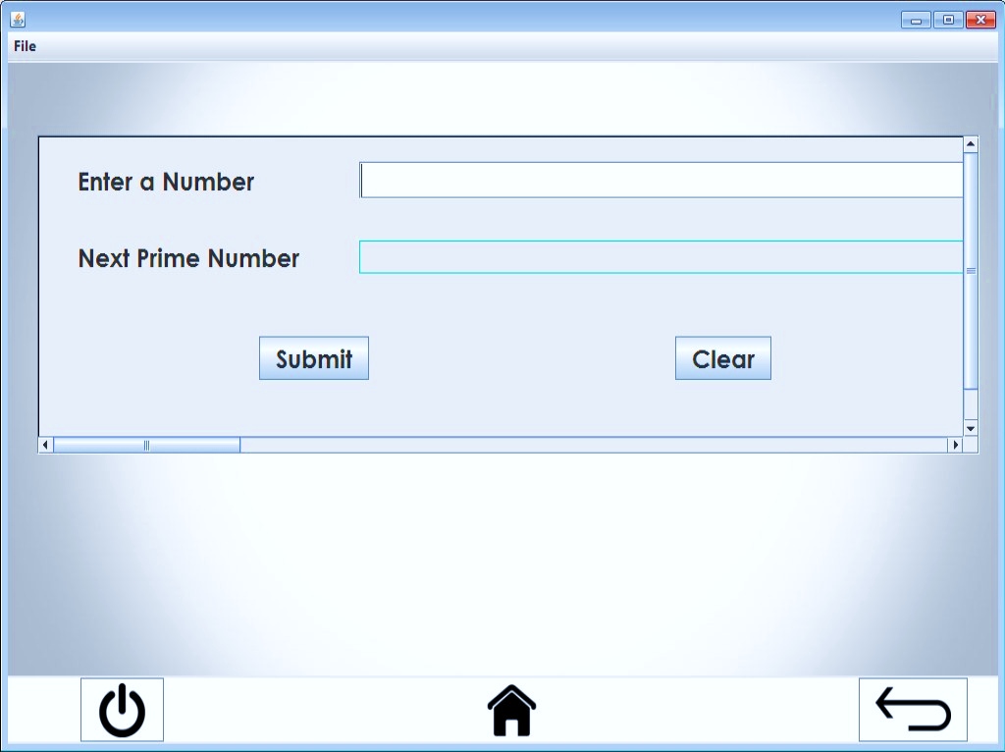**FRAME 14 (NEXT PRIME NO.)**

CODING:

package legionnaire_os;

import java.math.BigInteger;

import javax.swing.JOptionPane;

/* @author Mandeep M. Dalavi */

public class Next_Prime_No_App extends javax.swing.JFrame {

public Next_Prime_No_App() {

initComponents(); }

-----------------------------------------------------------------------------------------------------------

private void BackbuttonActionPerformed(java.awt.event.ActionEvent evt) {

new Apps().setVisible(true);

this.setVisible(false);

}

-----------------------------------------------------------------------------------------------------------

private void SubmitActionPerformed(java.awt.event.ActionEvent evt) {

BigInteger n = new BigInteger(Enterno.getText());

BigInteger p = new BigInteger("" + n.nextProbablePrime());

Nextno.setText(p + "");

}

-----------------------------------------------------------------------------------------------------------

private void JumpHomemenuActionPerformed(java.awt.event.ActionEvent evt) {

new Home().setVisible(true);

this.setVisible(false);

}

-----------------------------------------------------------------------------------------------------------

private void JumpAppmenuActionPerformed(java.awt.event.ActionEvent evt) {

new Apps().setVisible(true);

this.setVisible(false); }

private void ExitOSmenuActionPerformed(java.awt.event.ActionEvent evt) {

if(JOptionPane.showConfirmDialog(this, "Are you sure you want to exit?", "Confirmation", JOptionPane.YES_NO_CANCEL_OPTION)==JOptionPane.YES_OPTION)

{

System.exit(0);

}

}

-----------------------------------------------------------------------------------------------------------

private void formWindowActivated(java.awt.event.WindowEvent evt) {

this.setResizable(true);

this.setSize(1025, 707);

}

-----------------------------------------------------------------------------------------------------------

private void HomebuttonActionPerformed(java.awt.event.ActionEvent evt) {

new Home().setVisible(true);

this.setVisible(false);

}

-----------------------------------------------------------------------------------------------------------

private void PowerbuttonActionPerformed(java.awt.event.ActionEvent evt) {

if(JOptionPane.showConfirmDialog(this, "Are you sure you want to exit?", "Confirmation", JOptionPane.YES_NO_CANCEL_OPTION)==JOptionPane.YES_OPTION)

{ System.exit(0); }

}

-----------------------------------------------------------------------------------------------------------

private void ClearActionPerformed(java.awt.event.ActionEvent evt) {

Enterno.setText("");

Nextno.setText("");

}

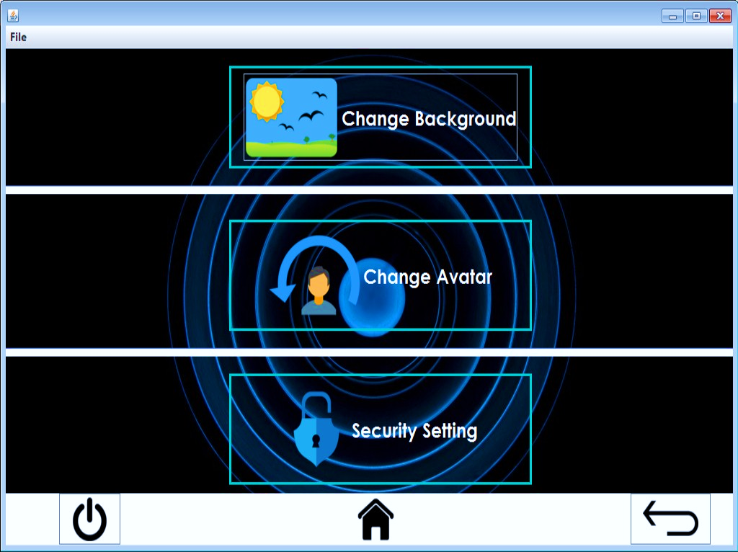**FRAME 15 (SETTING APP)**

CODING:

package legionnaire_os;

import javax.swing.JOptionPane;

/* @author Mandeep M. Dalavi */

public class Setting_App extends javax.swing.JFrame {

public Setting_App() {

initComponents();

}

-----------------------------------------------------------------------------------------------------------

private void BackbuttonActionPerformed(java.awt.event.ActionEvent evt) {

new Apps().setVisible(true);

this.setVisible(false);

}

-----------------------------------------------------------------------------------------------------------

private void ChangeBackgroundbuttonActionPerformed(java.awt.event.ActionEvent evt) {

new Change_Background().setVisible(true);

this.setVisible(false);

}

-----------------------------------------------------------------------------------------------------------

private void ChangeAvatarbuttonActionPerformed(java.awt.event.ActionEvent evt) {

new Change_Avatar().setVisible(true);

this.setVisible(false);

}

-----------------------------------------------------------------------------------------------------------

private void SecuritySettingbuttonActionPerformed(java.awt.event.ActionEvent evt) {

new Security_Setting().setVisible(true);

this.setVisible(false); }

private void PowerbuttonActionPerformed(java.awt.event.ActionEvent evt) {

if(JOptionPane.showConfirmDialog(this, "Are you sure you want to exit?", "Confirmation", JOptionPane.YES_NO_CANCEL_OPTION)==JOptionPane.YES_OPTION)

{

System.exit(0);

}

}

-----------------------------------------------------------------------------------------------------------

private void HomebuttonActionPerformed(java.awt.event.ActionEvent evt) {

new Home().setVisible(true);

this.setVisible(false);

}

-----------------------------------------------------------------------------------------------------------

private void formWindowActivated(java.awt.event.WindowEvent evt) {

this.setResizable(true);

this.setSize(1025, 646);

}

-----------------------------------------------------------------------------------------------------------

private void JumpHomemenuActionPerformed(java.awt.event.ActionEvent evt) {

new Home().setVisible(true);

this.setVisible(false);

}

-----------------------------------------------------------------------------------------------------------

private void JumpAppmenuActionPerformed(java.awt.event.ActionEvent evt) {

new Apps().setVisible(true);

this.setVisible(false);

}

private void ExitOSmenuActionPerformed(java.awt.event.ActionEvent evt) {

if(JOptionPane.showConfirmDialog(this, "Are you sure you want to exit?", "Confirmation", JOptionPane.YES_NO_CANCEL_OPTION)==JOptionPane.YES_OPTION)

{

System.exit(0);

}

}

-----------------------------------------------------------------------------------------------------------

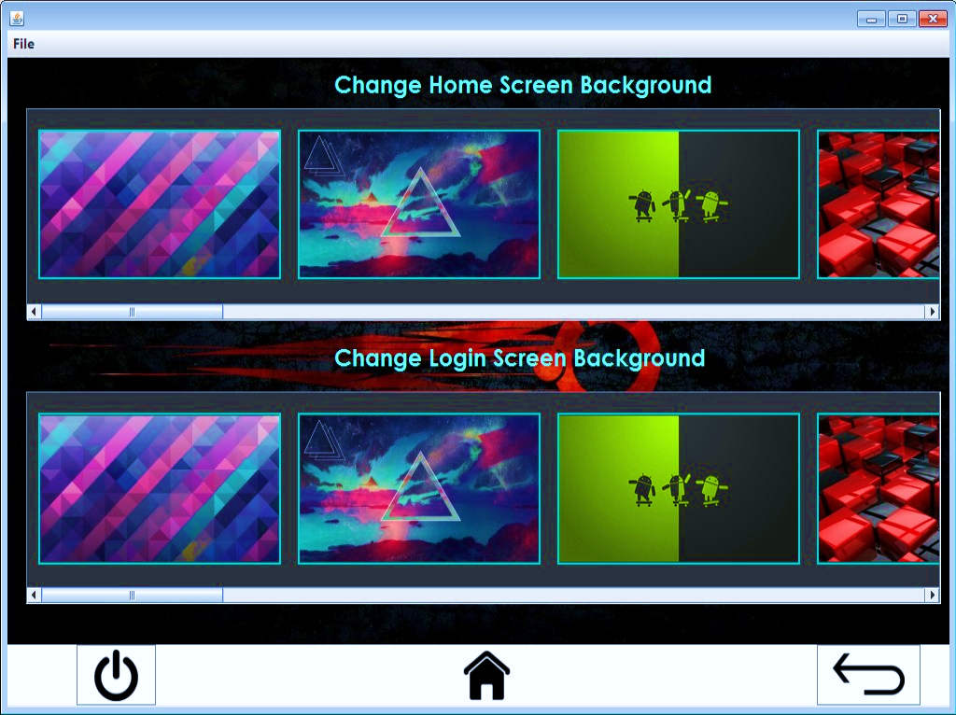**FRAME 16 (CHANGE BACKGROUND)**

CODING:

package legionnaire_os;

import java.sql.*;

import javax.swing.JOptionPane;

/* @author Mandeep M. Dalavi */

public class Change_Background extends javax.swing.JFrame {

public Change_Background() {

initComponents();

}

-----------------------------------------------------------------------------------------------------------

private void BackbuttonActionPerformed(java.awt.event.ActionEvent evt) {

new Setting_App().setVisible(true);

this.setVisible(false);

}

-----------------------------------------------------------------------------------------------------------

private void JumpHomemenuActionPerformed(java.awt.event.ActionEvent evt) {

new Home().setVisible(true);

this.setVisible(false);

}

-----------------------------------------------------------------------------------------------------------

private void JumpAppmenuActionPerformed(java.awt.event.ActionEvent evt) {

new Apps().setVisible(true);

this.setVisible(false);

}

-----------------------------------------------------------------------------------------------------------

private void ExitOSmenuActionPerformed(java.awt.event.ActionEvent evt) {

if(JOptionPane.showConfirmDialog(this, "Are you sure you want to exit?", "Confirmation", JOptionPane.YES_NO_CANCEL_OPTION)==JOptionPane.YES_OPTION)

{

System.exit(0);

}

}

-----------------------------------------------------------------------------------------------------------

private void formWindowActivated(java.awt.event.WindowEvent evt) {

this.setResizable(true);

this.setSize(1025, 707);

}

-----------------------------------------------------------------------------------------------------------

private void HomebuttonActionPerformed(java.awt.event.ActionEvent evt) {

new Home().setVisible(true);

this.setVisible(false);

}

-----------------------------------------------------------------------------------------------------------

private void PowerbuttonActionPerformed(java.awt.event.ActionEvent evt) {

if(JOptionPane.showConfirmDialog(this, "Are you sure you want to exit?", "Confirmation", JOptionPane.YES_NO_CANCEL_OPTION)==JOptionPane.YES_OPTION)

{

System.exit(0);

}

}

-----------------------------------------------------------------------------------------------------------

private void homebackground1MouseClicked(java.awt.event.MouseEvent evt) {

try

{

Class.forName("java.sql.Driver");

Connection con = (Connection) DriverManager.getConnection("jdbc:mysql://localhost:3306/legionnaire", "root", "admin");

Statement stmt = (Statement) con.createStatement();

String query = "Update backgrounds set homescreen='back1.jpg';";

stmt.executeUpdate(query);

JOptionPane.showMessageDialog(this, "Background set successfully!", "Success", JOptionPane.INFORMATION_MESSAGE);

}

catch (Exception e)

{

JOptionPane.showMessageDialog(this, “Error in Connectivity!”);

}

}

-----------------------------------------------------------------------------------------------------------

private void homebackground2MouseClicked(java.awt.event.MouseEvent evt) {

try

{

Class.forName("java.sql.Driver");

Connection con = (Connection) DriverManager.getConnection("jdbc:mysql://localhost:3306/legionnaire", "root", "admin");

Statement stmt = (Statement) con.createStatement();

String query = "Update backgrounds set homescreen='back2.jpg';";

stmt.executeUpdate(query);

JOptionPane.showMessageDialog(this, "Background set successfully!", "Success", JOptionPane.INFORMATION_MESSAGE);

}

catch (Exception e)

{

JOptionPane.showMessageDialog(this, “Error in Connectivity!”);

}

}

private void homebackground3MouseClicked(java.awt.event.MouseEvent evt) {

try {

Class.forName("java.sql.Driver");

Connection con = (Connection) DriverManager.getConnection("jdbc:mysql://localhost:3306/legionnaire", "root", "admin");

Statement stmt = (Statement) con.createStatement();

String query = "Update backgrounds set homescreen='back3.jpg';";

stmt.executeUpdate(query);

JOptionPane.showMessageDialog(this, "Background set successfully!", "Success", JOptionPane.INFORMATION_MESSAGE);

}

catch (Exception e) {

JOptionPane.showMessageDialog(this, “Error in Connectivity!”);

}

}

-----------------------------------------------------------------------------------------------------------

private void homebackground4MouseClicked(java.awt.event.MouseEvent evt) {

try {

Class.forName("java.sql.Driver");

Connection con = (Connection) DriverManager.getConnection("jdbc:mysql://localhost:3306/legionnaire", "root", "admin");

Statement stmt = (Statement) con.createStatement();

String query = "Update backgrounds set homescreen='back4.jpg';";

stmt.executeUpdate(query);

JOptionPane.showMessageDialog(this, "Background set successfully!", "Success", JOptionPane.INFORMATION_MESSAGE);

}

catch (Exception e) {

JOptionPane.showMessageDialog(this, “Error in Connectivity!”);

} }

private void homebackground5MouseClicked(java.awt.event.MouseEvent evt) {

try {

Class.forName("java.sql.Driver");

Connection con = (Connection) DriverManager.getConnection("jdbc:mysql://localhost:3306/legionnaire", "root", "admin");

Statement stmt = (Statement) con.createStatement();

String query = "Update backgrounds set homescreen='back5.jpg';";

stmt.executeUpdate(query);

JOptionPane.showMessageDialog(this, "Background set successfully!", "Success", JOptionPane.INFORMATION_MESSAGE);

}

catch (Exception e) {

JOptionPane.showMessageDialog(this, “Error in Connectivity!”);

}

}

-----------------------------------------------------------------------------------------------------------

private void homebackground6MouseClicked(java.awt.event.MouseEvent evt) {

try {

Class.forName("java.sql.Driver");

Connection con = (Connection) DriverManager.getConnection("jdbc:mysql://localhost:3306/legionnaire", "root", "admin");

Statement stmt = (Statement) con.createStatement();

String query = "Update backgrounds set homescreen='back6.jpg';";

stmt.executeUpdate(query);

JOptionPane.showMessageDialog(this, "Background set successfully!", "Success", JOptionPane.INFORMATION_MESSAGE);

}

catch (Exception e) {

JOptionPane.showMessageDialog(this, “Error in Connectivity!”);

} }

private void homebackground8MouseClicked(java.awt.event.MouseEvent evt) {

try {

Class.forName("java.sql.Driver");

Connection con = (Connection) DriverManager.getConnection("jdbc:mysql://localhost:3306/legionnaire", "root", "admin");

Statement stmt = (Statement) con.createStatement();

String query = "Update backgrounds set homescreen='back8.jpg';";

stmt.executeUpdate(query);

JOptionPane.showMessageDialog(this, "Background set successfully!", "Success", JOptionPane.INFORMATION_MESSAGE);

}

catch (Exception e) {

JOptionPane.showMessageDialog(this, “Error in Connectivity!”);

}

}

-----------------------------------------------------------------------------------------------------------

private void homebackground9MouseClicked(java.awt.event.MouseEvent evt) {

try {

Class.forName("java.sql.Driver");

Connection con = (Connection) DriverManager.getConnection("jdbc:mysql://localhost:3306/legionnaire", "root", "admin");

Statement stmt = (Statement) con.createStatement();

String query = "Update backgrounds set homescreen='back9.jpg';";

stmt.executeUpdate(query);

JOptionPane.showMessageDialog(this, "Background set successfully!", "Success", JOptionPane.INFORMATION_MESSAGE);

}

catch (Exception e) {

JOptionPane.showMessageDialog(this, “Error in Connectivity!”);

} }

private void homebackground10MouseClicked(java.awt.event.MouseEvent evt) {

try {

Class.forName("java.sql.Driver");

Connection con = (Connection) DriverManager.getConnection("jdbc:mysql://localhost:3306/legionnaire", "root", "admin");

Statement stmt = (Statement) con.createStatement();

String query = "Update backgrounds set homescreen='back10.jpg';";

stmt.executeUpdate(query);

JOptionPane.showMessageDialog(this, "Background set successfully!", "Success", JOptionPane.INFORMATION_MESSAGE);

}

catch (Exception e) {

JOptionPane.showMessageDialog(this, “Error in Connectivity!”);

}

}

-----------------------------------------------------------------------------------------------------------

private void homebackground11MouseClicked(java.awt.event.MouseEvent evt) {

try {

Class.forName("java.sql.Driver");

Connection con = (Connection) DriverManager.getConnection("jdbc:mysql://localhost:3306/legionnaire", "root", "admin");

Statement stmt = (Statement) con.createStatement();

String query = "Update backgrounds set homescreen='back11.jpg';";

stmt.executeUpdate(query);

JOptionPane.showMessageDialog(this, "Background set successfully!", "Success", JOptionPane.INFORMATION_MESSAGE);

}

catch (Exception e) {

JOptionPane.showMessageDialog(this, “Error in Connectivity!”);

} }

private void homebackground12MouseClicked(java.awt.event.MouseEvent evt) {

try {

Class.forName("java.sql.Driver");

Connection con = (Connection) DriverManager.getConnection("jdbc:mysql://localhost:3306/legionnaire", "root", "admin");

Statement stmt = (Statement) con.createStatement();

String query = "Update backgrounds set homescreen='back12.jpg';";

stmt.executeUpdate(query);

JOptionPane.showMessageDialog(this, "Background set successfully!", "Success", JOptionPane.INFORMATION_MESSAGE);

}

catch (Exception e) {

JOptionPane.showMessageDialog(this, “Error in Connectivity!”);

}

}

-----------------------------------------------------------------------------------------------------------

private void homebackground13MouseClicked(java.awt.event.MouseEvent evt) {

try {

Class.forName("java.sql.Driver");

Connection con = (Connection) DriverManager.getConnection("jdbc:mysql://localhost:3306/legionnaire", "root", "admin");

Statement stmt = (Statement) con.createStatement();

String query = "Update backgrounds set homescreen='back13.jpg';";

stmt.executeUpdate(query);

JOptionPane.showMessageDialog(this, "Background set successfully!", "Success", JOptionPane.INFORMATION_MESSAGE);

}

catch (Exception e) {

JOptionPane.showMessageDialog(this, “Error in Connectivity!”);

} }

private void homebackground14MouseClicked(java.awt.event.MouseEvent evt) {

try {

Class.forName("java.sql.Driver");

Connection con = (Connection) DriverManager.getConnection("jdbc:mysql://localhost:3306/legionnaire", "root", "admin");

Statement stmt = (Statement) con.createStatement();

String query = "Update backgrounds set homescreen='back14.jpg';";

stmt.executeUpdate(query);

JOptionPane.showMessageDialog(this, "Background set successfully!", "Success", JOptionPane.INFORMATION_MESSAGE);

}

catch (Exception e) {

JOptionPane.showMessageDialog(this, “Error in Connectivity!”);

}

}

-----------------------------------------------------------------------------------------------------------

private void homebackground15MouseClicked(java.awt.event.MouseEvent evt) {

try {

Class.forName("java.sql.Driver");

Connection con = (Connection) DriverManager.getConnection("jdbc:mysql://localhost:3306/legionnaire", "root", "admin");

Statement stmt = (Statement) con.createStatement();

String query = "Update backgrounds set homescreen='back15.jpg';";

stmt.executeUpdate(query);

JOptionPane.showMessageDialog(this, "Background set successfully!", "Success", JOptionPane.INFORMATION_MESSAGE);

}

catch (Exception e) {

JOptionPane.showMessageDialog(this, “Error in Connectivity!”);

} }

private void homebackground16MouseClicked(java.awt.event.MouseEvent evt) {

try {

Class.forName("java.sql.Driver");

Connection con = (Connection) DriverManager.getConnection("jdbc:mysql://localhost:3306/legionnaire", "root", "admin");

Statement stmt = (Statement) con.createStatement();

String query = "Update backgrounds set homescreen='back16.jpg';";

stmt.executeUpdate(query);

JOptionPane.showMessageDialog(this, "Background set successfully!", "Success", JOptionPane.INFORMATION_MESSAGE);

}

catch (Exception e) {

JOptionPane.showMessageDialog(this, “Error in Connectivity!”);

}

}

-----------------------------------------------------------------------------------------------------------

private void homebackground17MouseClicked(java.awt.event.MouseEvent evt) {

try {

Class.forName("java.sql.Driver");

Connection con = (Connection) DriverManager.getConnection("jdbc:mysql://localhost:3306/legionnaire", "root", "admin");

Statement stmt = (Statement) con.createStatement();

String query = "Update backgrounds set homescreen='back17.jpg';";

stmt.executeUpdate(query);

JOptionPane.showMessageDialog(this, "Background set successfully!", "Success", JOptionPane.INFORMATION_MESSAGE);

}

catch (Exception e) {

JOptionPane.showMessageDialog(this, “Error in Connectivity!”);

} }

private void homebackground18MouseClicked(java.awt.event.MouseEvent evt) {

try {

Class.forName("java.sql.Driver");

Connection con = (Connection) DriverManager.getConnection("jdbc:mysql://localhost:3306/legionnaire", "root", "admin");

Statement stmt = (Statement) con.createStatement();

String query = "Update backgrounds set homescreen='back18.jpg';";

stmt.executeUpdate(query);

JOptionPane.showMessageDialog(this, "Background set successfully!", "Success", JOptionPane.INFORMATION_MESSAGE);

}

catch (Exception e) {

JOptionPane.showMessageDialog(this, “Error in Connectivity!”);

}

}

-----------------------------------------------------------------------------------------------------------

private void loginbackground1MouseClicked(java.awt.event.MouseEvent evt) {

try {

Class.forName("java.sql.Driver");

Connection con = (Connection) DriverManager.getConnection("jdbc:mysql://localhost:3306/legionnaire", "root", "admin");

Statement stmt = (Statement) con.createStatement();

String query = "Update backgrounds set loginscreen='back1.jpg';";

stmt.executeUpdate(query);

JOptionPane.showMessageDialog(this, "Background set successfully!", "Success", JOptionPane.INFORMATION_MESSAGE);

}

catch (Exception e) {

JOptionPane.showMessageDialog(this, “Error in Connectivity!”);

} }

private void loginbackground2MouseClicked(java.awt.event.MouseEvent evt) {

try {

Class.forName("java.sql.Driver");

Connection con = (Connection) DriverManager.getConnection("jdbc:mysql://localhost:3306/legionnaire", "root", "admin");

Statement stmt = (Statement) con.createStatement();

String query = "Update backgrounds set loginscreen='back2.jpg';";

stmt.executeUpdate(query);

JOptionPane.showMessageDialog(this, "Background set successfully!", "Success", JOptionPane.INFORMATION_MESSAGE);

}

catch (Exception e) {

JOptionPane.showMessageDialog(this, “Error in Connectivity!”);

}

}

-----------------------------------------------------------------------------------------------------------

private void loginbackground3MouseClicked(java.awt.event.MouseEvent evt) {

try {

Class.forName("java.sql.Driver");

Connection con = (Connection) DriverManager.getConnection("jdbc:mysql://localhost:3306/legionnaire", "root", "admin");

Statement stmt = (Statement) con.createStatement();

String query = "Update backgrounds set loginscreen='back3.jpg';";

stmt.executeUpdate(query);

JOptionPane.showMessageDialog(this, "Background set successfully!", "Success", JOptionPane.INFORMATION_MESSAGE);

}

catch (Exception e) {

JOptionPane.showMessageDialog(this, “Error in Connectivity!”);

} }

private void loginbackground4MouseClicked(java.awt.event.MouseEvent evt) {

try {

Class.forName("java.sql.Driver");

Connection con = (Connection) DriverManager.getConnection("jdbc:mysql://localhost:3306/legionnaire", "root", "admin");

Statement stmt = (Statement) con.createStatement();

String query = "Update backgrounds set loginscreen='back4.jpg';";

stmt.executeUpdate(query);

JOptionPane.showMessageDialog(this, "Background set successfully!", "Success", JOptionPane.INFORMATION_MESSAGE);

}

catch (Exception e) {

JOptionPane.showMessageDialog(this, “Error in Connectivity!”);

}

}

-----------------------------------------------------------------------------------------------------------

private void loginbackground5MouseClicked(java.awt.event.MouseEvent evt) {

try {

Class.forName("java.sql.Driver");

Connection con = (Connection) DriverManager.getConnection("jdbc:mysql://localhost:3306/legionnaire", "root", "admin");

Statement stmt = (Statement) con.createStatement();

String query = "Update backgrounds set loginscreen='back5.jpg';";

stmt.executeUpdate(query);

JOptionPane.showMessageDialog(this, "Background set successfully!", "Success", JOptionPane.INFORMATION_MESSAGE);

}

catch (Exception e) {

JOptionPane.showMessageDialog(this, “Error in Connectivity!”);

} }

private void loginbackground6MouseClicked(java.awt.event.MouseEvent evt) {

try {

Class.forName("java.sql.Driver");

Connection con = (Connection) DriverManager.getConnection("jdbc:mysql://localhost:3306/legionnaire", "root", "admin");

Statement stmt = (Statement) con.createStatement();

String query = "Update backgrounds set loginscreen='back6.jpg';";

stmt.executeUpdate(query);

JOptionPane.showMessageDialog(this, "Background set successfully!", "Success", JOptionPane.INFORMATION_MESSAGE);

}

catch (Exception e) {

JOptionPane.showMessageDialog(this, “Error in Connectivity!”);

}

}

-----------------------------------------------------------------------------------------------------------

private void loginbackground8MouseClicked(java.awt.event.MouseEvent evt) {

try {

Class.forName("java.sql.Driver");

Connection con = (Connection) DriverManager.getConnection("jdbc:mysql://localhost:3306/legionnaire", "root", "admin");

Statement stmt = (Statement) con.createStatement();

String query = "Update backgrounds set loginscreen='back8.jpg';";

stmt.executeUpdate(query);

JOptionPane.showMessageDialog(this, "Background set successfully!", "Success", JOptionPane.INFORMATION_MESSAGE);

}

catch (Exception e) {

JOptionPane.showMessageDialog(this, “Error in Connectivity!”);

} }

private void loginbackground9MouseClicked(java.awt.event.MouseEvent evt) {

try{

Class.forName("java.sql.Driver");

Connection con = (Connection) DriverManager.getConnection("jdbc:mysql://localhost:3306/legionnaire", "root", "admin");

Statement stmt = (Statement) con.createStatement();

String query = "Update backgrounds set loginscreen='back9.jpg';";

stmt.executeUpdate(query);

JOptionPane.showMessageDialog(this, "Background set successfully!", "Success", JOptionPane.INFORMATION_MESSAGE);

}

catch (Exception e) {

JOptionPane.showMessageDialog(this, “Error in Connectivity!”);

}

}

-----------------------------------------------------------------------------------------------------------

private void loginbackground10MouseClicked(java.awt.event.MouseEvent evt) {

try {

Class.forName("java.sql.Driver");

Connection con = (Connection) DriverManager.getConnection("jdbc:mysql://localhost:3306/legionnaire", "root", "admin");

Statement stmt = (Statement) con.createStatement();

String query = "Update backgrounds set loginscreen='back10.jpg';";

stmt.executeUpdate(query);

JOptionPane.showMessageDialog(this, "Background set successfully!", "Success", JOptionPane.INFORMATION_MESSAGE);

}

catch (Exception e) {

JOptionPane.showMessageDialog(this, “Error in Connectivity!”);

} }

private void loginbackground11MouseClicked(java.awt.event.MouseEvent evt) {

try {

Class.forName("java.sql.Driver");

Connection con = (Connection) DriverManager.getConnection("jdbc:mysql://localhost:3306/legionnaire", "root", "admin");

Statement stmt = (Statement) con.createStatement();

String query = "Update backgrounds set loginscreen='back11.jpg';";

stmt.executeUpdate(query);

JOptionPane.showMessageDialog(this, "Background set successfully!", "Success", JOptionPane.INFORMATION_MESSAGE);

}

catch (Exception e) {

JOptionPane.showMessageDialog(this, “Error in Connectivity!”);

}

}

-----------------------------------------------------------------------------------------------------------

private void loginbackground12MouseClicked(java.awt.event.MouseEvent evt) {

try {

Class.forName("java.sql.Driver");

Connection con = (Connection) DriverManager.getConnection("jdbc:mysql://localhost:3306/legionnaire", "root", "admin");

Statement stmt = (Statement) con.createStatement();

String query = "Update backgrounds set loginscreen='back12.jpg';";

stmt.executeUpdate(query);

JOptionPane.showMessageDialog(this, "Background set successfully!", "Success", JOptionPane.INFORMATION_MESSAGE);

}

catch (Exception e) {

JOptionPane.showMessageDialog(this, “Error in Connectivity!”);

} }

private void loginbackground13MouseClicked(java.awt.event.MouseEvent evt) {

try {

Class.forName("java.sql.Driver");

Connection con = (Connection) DriverManager.getConnection("jdbc:mysql://localhost:3306/legionnaire", "root", "admin");

Statement stmt = (Statement) con.createStatement();

String query = "Update backgrounds set loginscreen='back13.jpg';";

stmt.executeUpdate(query);

JOptionPane.showMessageDialog(this, "Background set successfully!", "Success", JOptionPane.INFORMATION_MESSAGE);

}

catch (Exception e) {

JOptionPane.showMessageDialog(this, “Error in Connectivity!”);

}

}

-----------------------------------------------------------------------------------------------------------

private void loginbackground14MouseClicked(java.awt.event.MouseEvent evt) {

try {

Class.forName("java.sql.Driver");

Connection con = (Connection) DriverManager.getConnection("jdbc:mysql://localhost:3306/legionnaire", "root", "admin");

Statement stmt = (Statement) con.createStatement();

String query = "Update backgrounds set loginscreen='back14.jpg';";

stmt.executeUpdate(query);

JOptionPane.showMessageDialog(this, "Background set successfully!", "Success", JOptionPane.INFORMATION_MESSAGE);

}

catch (Exception e) {

JOptionPane.showMessageDialog(this, “Error in Connectivity!”);

} }

private void loginbackground15MouseClicked(java.awt.event.MouseEvent evt) {

try {

Class.forName("java.sql.Driver");

Connection con = (Connection) DriverManager.getConnection("jdbc:mysql://localhost:3306/legionnaire", "root", "admin");

Statement stmt = (Statement) con.createStatement();

String query = "Update backgrounds set loginscreen='back15.jpg';";

stmt.executeUpdate(query);

JOptionPane.showMessageDialog(this, "Background set successfully!", "Success", JOptionPane.INFORMATION_MESSAGE);

}

catch (Exception e) {

JOptionPane.showMessageDialog(this, “Error in Connectivity!”);

}

}

-----------------------------------------------------------------------------------------------------------

private void loginbackground16MouseClicked(java.awt.event.MouseEvent evt) {

try {

Class.forName("java.sql.Driver");

Connection con = (Connection) DriverManager.getConnection("jdbc:mysql://localhost:3306/legionnaire", "root", "admin");

Statement stmt = (Statement) con.createStatement();

String query = "Update backgrounds set loginscreen='back16.jpg';";

stmt.executeUpdate(query);

JOptionPane.showMessageDialog(this, "Background set successfully!", "Success", JOptionPane.INFORMATION_MESSAGE);

}

catch (Exception e) {

JOptionPane.showMessageDialog(this, “Error in Connectivity!”);

} }

private void loginbackground17MouseClicked(java.awt.event.MouseEvent evt) {

try {

Class.forName("java.sql.Driver");

Connection con = (Connection) DriverManager.getConnection("jdbc:mysql://localhost:3306/legionnaire", "root", "admin");

Statement stmt = (Statement) con.createStatement();

String query = "Update backgrounds set loginscreen='back17.jpg';";

stmt.executeUpdate(query);

JOptionPane.showMessageDialog(this, "Background set successfully!", "Success", JOptionPane.INFORMATION_MESSAGE);

}

catch (Exception e) {

JOptionPane.showMessageDialog(this, “Error in Connectivity!”);

}

}

-----------------------------------------------------------------------------------------------------------

private void loginbackground18MouseClicked(java.awt.event.MouseEvent evt) {

try {

Class.forName("java.sql.Driver");

Connection con = (Connection) DriverManager.getConnection("jdbc:mysql://localhost:3306/legionnaire", "root", "admin");

Statement stmt = (Statement) con.createStatement();

String query = "Update backgrounds set loginscreen='back18.jpg';";

stmt.executeUpdate(query);

JOptionPane.showMessageDialog(this, "Background set successfully!", "Success", JOptionPane.INFORMATION_MESSAGE);

}

catch (Exception e) {

JOptionPane.showMessageDialog(this, “Error in Connectivity!”);

} }

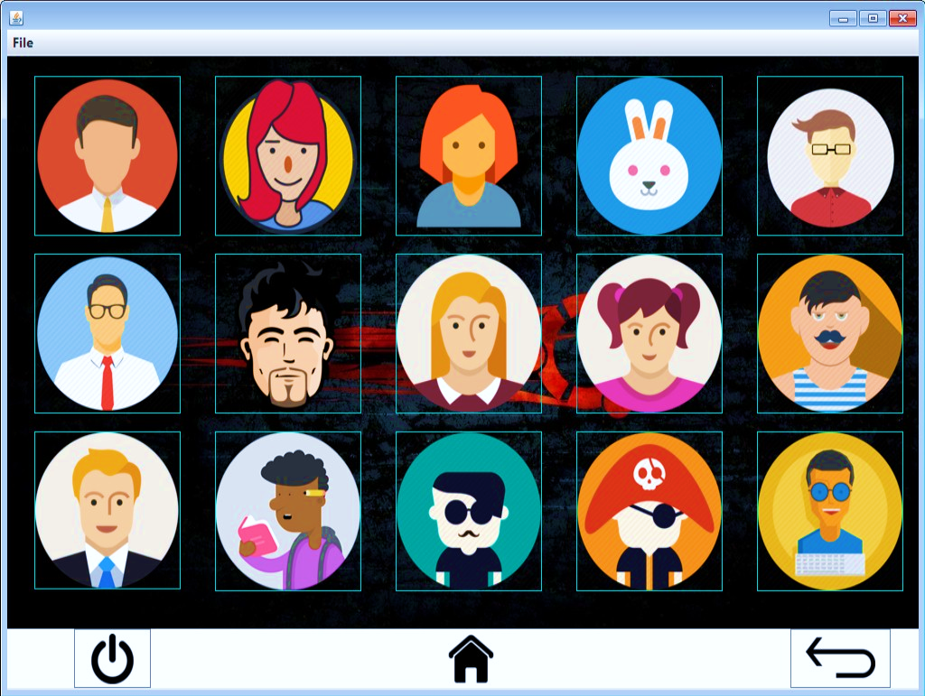**FRAME 17 (CHANGE AVATAR)**

CODING:

package legionnaire_os;

import java.sql.*;

import javax.swing.JOptionPane;

/* @author Mandeep M. Dalavi */

public class Change_Avatar extends javax.swing.JFrame {

public Change_Avatar() {

initComponents(); }

-----------------------------------------------------------------------------------------------------------

private void BackbuttonActionPerformed(java.awt.event.ActionEvent evt) {

new Setting_App().setVisible(true);

this.setVisible(false); }

-----------------------------------------------------------------------------------------------------------

private void JumpHomemenuActionPerformed(java.awt.event.ActionEvent evt) {

new Home().setVisible(true);

this.setVisible(false);

}

-----------------------------------------------------------------------------------------------------------

private void JumpAppmenuActionPerformed(java.awt.event.ActionEvent evt) {

new Apps().setVisible(true);

this.setVisible(false);

}

-----------------------------------------------------------------------------------------------------------

private void ExitOSmenuActionPerformed(java.awt.event.ActionEvent evt) {

if(JOptionPane.showConfirmDialog(this, "Are you sure you want to exit?", "Confirmation", JOptionPane.YES_NO_CANCEL_OPTION)==JOptionPane.YES_OPTION)

{ System.exit(0); }

}

private void formWindowActivated(java.awt.event.WindowEvent evt) {

this.setResizable(true);

this.setSize(1025, 707);

}

-----------------------------------------------------------------------------------------------------------

private void HomebuttonActionPerformed(java.awt.event.ActionEvent evt) {

new Home().setVisible(true);

this.setVisible(false);

}

-----------------------------------------------------------------------------------------------------------

private void PowerbuttonActionPerformed(java.awt.event.ActionEvent evt) {

if(JOptionPane.showConfirmDialog(this, "Are you sure you want to exit?", "Confirmation", JOptionPane.YES_NO_CANCEL_OPTION)==JOptionPane.YES_OPTION)

{ System.exit(0); } }

-----------------------------------------------------------------------------------------------------------

private void user1buttonActionPerformed(java.awt.event.ActionEvent evt) {

try {

Class.forName("java.sql.Driver");

Connection con = (Connection) DriverManager.getConnection("jdbc:mysql://localhost:3306/legionnaire", "root", "admin");

Statement stmt = (Statement) con.createStatement();

String query = "UPDATE UserAvatar SET avatar='user1.png';";

stmt.executeUpdate(query);

JOptionPane.showMessageDialog(this, "Avatar set successfully!", "Success", JOptionPane.INFORMATION_MESSAGE);

}

catch (Exception e) {

JOptionPane.showMessageDialog(this, “Error in Connectivity!”);

} }

private void user2buttonActionPerformed(java.awt.event.ActionEvent evt) {

try {

Class.forName("java.sql.Driver");

Connection con = (Connection) DriverManager.getConnection("jdbc:mysql://localhost:3306/legionnaire", "root", "admin");

Statement stmt = (Statement) con.createStatement();

String query = "UPDATE UserAvatar SET avatar='user2.png';";

stmt.executeUpdate(query);

JOptionPane.showMessageDialog(this, "Avatar set successfully!", "Success", JOptionPane.INFORMATION_MESSAGE);

}

catch (Exception e) {

JOptionPane.showMessageDialog(this, “Error in Connectivity!”);

}

}

-----------------------------------------------------------------------------------------------------------

private void user3buttonActionPerformed(java.awt.event.ActionEvent evt) {

try {

Class.forName("java.sql.Driver");

Connection con = (Connection) DriverManager.getConnection("jdbc:mysql://localhost:3306/legionnaire", "root", "admin");

Statement stmt = (Statement) con.createStatement();

String query = "UPDATE UserAvatar SET avatar='user3.png';";

stmt.executeUpdate(query);

JOptionPane.showMessageDialog(this, "Avatar set successfully!", "Success", JOptionPane.INFORMATION_MESSAGE);

}

catch (Exception e) {

JOptionPane.showMessageDialog(this, “Error in Connectivity!”);

} }

private void user4buttonActionPerformed(java.awt.event.ActionEvent evt) {

try {

Class.forName("java.sql.Driver");

Connection con = (Connection) DriverManager.getConnection("jdbc:mysql://localhost:3306/legionnaire", "root", "admin");

Statement stmt = (Statement) con.createStatement();

String query = "UPDATE UserAvatar SET avatar='user4.png';";

stmt.executeUpdate(query);

JOptionPane.showMessageDialog(this, "Avatar set successfully!", "Success", JOptionPane.INFORMATION_MESSAGE);

}

catch (Exception e) {

JOptionPane.showMessageDialog(this, “Error in Connectivity!”);

}

}

-----------------------------------------------------------------------------------------------------------

private void user5buttonActionPerformed(java.awt.event.ActionEvent evt) {

try {

Class.forName("java.sql.Driver");

Connection con = (Connection) DriverManager.getConnection("jdbc:mysql://localhost:3306/legionnaire", "root", "admin");

Statement stmt = (Statement) con.createStatement();

String query = "UPDATE UserAvatar SET avatar='user5.png';";

stmt.executeUpdate(query);

JOptionPane.showMessageDialog(this, "Avatar set successfully!", "Success", JOptionPane.INFORMATION_MESSAGE);

}

catch (Exception e) {

JOptionPane.showMessageDialog(this, “Error in Connectivity!”);

} }

private void user6buttonActionPerformed(java.awt.event.ActionEvent evt) {

try {

Class.forName("java.sql.Driver");

Connection con = (Connection) DriverManager.getConnection("jdbc:mysql://localhost:3306/legionnaire", "root", "admin");

Statement stmt = (Statement) con.createStatement();

String query = "UPDATE UserAvatar SET avatar='user6.png';";

stmt.executeUpdate(query);

JOptionPane.showMessageDialog(this, "Avatar set successfully!", "Success", JOptionPane.INFORMATION_MESSAGE);

}

catch (Exception e) {

JOptionPane.showMessageDialog(this, “Error in Connectivity!”);

}

}

-----------------------------------------------------------------------------------------------------------

private void user7buttonActionPerformed(java.awt.event.ActionEvent evt) {

try {

Class.forName("java.sql.Driver");

Connection con = (Connection) DriverManager.getConnection("jdbc:mysql://localhost:3306/legionnaire", "root", "admin");

Statement stmt = (Statement) con.createStatement();

String query = "UPDATE UserAvatar SET avatar='user7.png';";

stmt.executeUpdate(query);

JOptionPane.showMessageDialog(this, "Avatar set successfully!", "Success", JOptionPane.INFORMATION_MESSAGE);

}

catch (Exception e) {

JOptionPane.showMessageDialog(this, “Error in Connectivity!”);

} }

private void user8buttonActionPerformed(java.awt.event.ActionEvent evt) {

try {

Class.forName("java.sql.Driver");

Connection con = (Connection )DriverManager.getConnection("jdbc:mysql://localhost:3306/legionnaire", "root", "admin");

Statement stmt = (Statement) con.createStatement();

String query = "UPDATE UserAvatar SET avatar='user8.png';";

stmt.executeUpdate(query);

JOptionPane.showMessageDialog(this, "Avatar set successfully!", "Success", JOptionPane.INFORMATION_MESSAGE);

}

catch (Exception e) {

JOptionPane.showMessageDialog(this, “Error in Connectivity!”);

}

}

----------------------------------------------------------------------------------------------------------

private void user9buttonActionPerformed(java.awt.event.ActionEvent evt) {

try {

Class.forName("java.sql.Driver");

Connection con = (Connection) DriverManager.getConnection("jdbc:mysql://localhost:3306/legionnaire", "root", "admin");

Statement stmt = (Statement) con.createStatement();

String query = "UPDATE UserAvatar SET avatar='user9.png';";

stmt.executeUpdate(query);

JOptionPane.showMessageDialog(this, "Avatar set successfully!", "Success", JOptionPane.INFORMATION_MESSAGE);

}

catch (Exception e) {

JOptionPane.showMessageDialog(this, “Error in Connectivity!”);

} }

private void user10buttonActionPerformed(java.awt.event.ActionEvent evt) {

try {

Class.forName("java.sql.Driver");

Connection con = (Connection) DriverManager.getConnection("jdbc:mysql://localhost:3306/legionnaire", "root", "admin");

Statement stmt = (Statement) con.createStatement();

String query = "UPDATE UserAvatar SET avatar='user10.png';";

stmt.executeUpdate(query);

JOptionPane.showMessageDialog(this, "Avatar set successfully!", "Success", JOptionPane.INFORMATION_MESSAGE);

}

catch (Exception e) {

JOptionPane.showMessageDialog(this, “Error in Connectivity!”);

}

}

-----------------------------------------------------------------------------------------------------------

private void user11buttonActionPerformed(java.awt.event.ActionEvent evt) {

try {

Class.forName("java.sql.Driver");

Connection con = (Connection) DriverManager.getConnection("jdbc:mysql://localhost:3306/legionnaire", "root", "admin");

Statement stmt = (Statement) con.createStatement();

String query = "UPDATE UserAvatar SET avatar='user11.png';";

stmt.executeUpdate(query);

JOptionPane.showMessageDialog(this, "Avatar set successfully!", "Success", JOptionPane.INFORMATION_MESSAGE);

}

catch (Exception e) {

JOptionPane.showMessageDialog(this, “Error in Connectivity!”);

} }

private void user12buttonActionPerformed(java.awt.event.ActionEvent evt) {

try {

Class.forName("java.sql.Driver");

Connection con = (Connection) DriverManager.getConnection("jdbc:mysql://localhost:3306/legionnaire", "root", "admin");

Statement stmt = (Statement) con.createStatement();

String query = "UPDATE UserAvatar SET avatar='user12.png';";

stmt.executeUpdate(query);

JOptionPane.showMessageDialog(this, "Avatar set successfully!", "Success", JOptionPane.INFORMATION_MESSAGE);

}

catch (Exception e) {

JOptionPane.showMessageDialog(this, “Error in Connectivity!”);

}

}

-----------------------------------------------------------------------------------------------------------

private void user13buttonActionPerformed(java.awt.event.ActionEvent evt) {

try {

Class.forName("java.sql.Driver");

Connection con = (Connection) DriverManager.getConnection("jdbc:mysql://localhost:3306/legionnaire", "root", "admin");

Statement stmt = (Statement) con.createStatement();

String query = "UPDATE UserAvatar SET avatar='user13.png';";

stmt.executeUpdate(query);

JOptionPane.showMessageDialog(this, "Avatar set successfully!", "Success", JOptionPane.INFORMATION_MESSAGE);

}

catch (Exception e) {

JOptionPane.showMessageDialog(this, “Error in Connectivity!”);

} }

private void user14buttonActionPerformed(java.awt.event.ActionEvent evt) {

try {

Class.forName("java.sql.Driver");

Connection con = (Connection) DriverManager.getConnection("jdbc:mysql://localhost:3306/legionnaire", "root", "admin");

Statement stmt = (Statement) con.createStatement();

String query = "UPDATE UserAvatar SET avatar='user14.png';";

stmt.executeUpdate(query);

JOptionPane.showMessageDialog(this, "Avatar set successfully!", "Success", JOptionPane.INFORMATION_MESSAGE);

}

catch (Exception e) {

JOptionPane.showMessageDialog(this, “Error in Connectivity!”);

}

}

-----------------------------------------------------------------------------------------------------------

private void user15buttonActionPerformed(java.awt.event.ActionEvent evt) {

try {

Class.forName("java.sql.Driver");

Connection con = (Connection) DriverManager.getConnection("jdbc:mysql://localhost:3306/legionnaire", "root", "admin");

Statement stmt = (Statement) con.createStatement();

String query = "UPDATE UserAvatar SET avatar='user15.png';";

stmt.executeUpdate(query);

JOptionPane.showMessageDialog(this, "Avatar set successfully!", "Success", JOptionPane.INFORMATION_MESSAGE);

}

catch (Exception e) {

JOptionPane.showMessageDialog(this, “Error in Connectivity!”);

} }

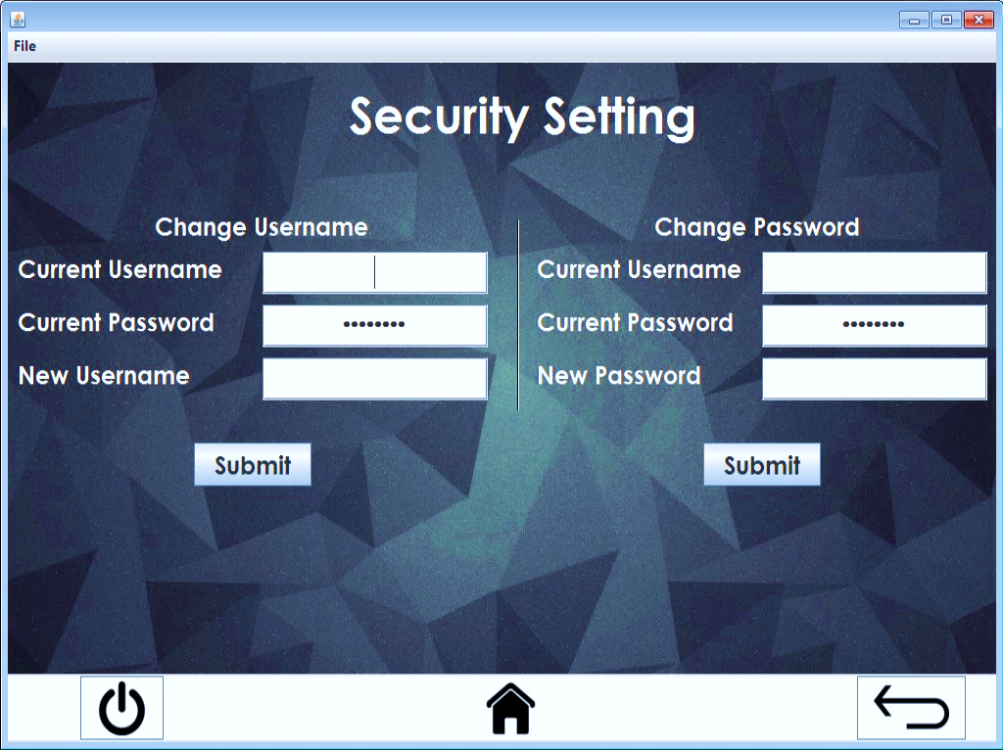**FRAME 18 (SECURITY SETTING)**

CODING:

package legionnaire_os;

import java.sql.*;

import java.awt.Color;

import javax.swing.JOptionPane;

/* @author Mandeep M. Dalavi */

public class Security_Setting extends javax.swing.JFrame {

String curusername, curpassword;

String user, pass, newuser, newpass;

public Security_Setting() {

initComponents();

//---------------------JDBC part getting username and password--------------------//

try {

Class.forName("java.sql.Driver");

Connection con = (Connection) DriverManager.getConnection("jdbc:mysql://localhost:3306/legionnaire", "root", "admin");

Statement stmt = (Statement) con.createStatement();

String query = "Select * from userpass";

ResultSet rs = stmt.executeQuery(query);

if (rs.first())

{

curusername = rs.getString(1);

curpassword = rs.getString(2);

}

}

catch (Exception e) {

JOptionPane.showMessageDialog(this, "Error in Connectivity!");

} }

private void JumpHomemenuActionPerformed(java.awt.event.ActionEvent evt) {

new Home().setVisible(true);

this.setVisible(false);

}

-----------------------------------------------------------------------------------------------------------

private void JumpAppmenuActionPerformed(java.awt.event.ActionEvent evt) {

new Apps().setVisible(true);

this.setVisible(false);

}

-----------------------------------------------------------------------------------------------------------

private void ExitOSmenuActionPerformed(java.awt.event.ActionEvent evt) {

if(JOptionPane.showConfirmDialog(this, "Are you sure you want to exit?", "Confirmation", JOptionPane.YES_NO_CANCEL_OPTION)==JOptionPane.YES_OPTION)

{

System.exit(0);

}

}

-----------------------------------------------------------------------------------------------------------

private void HomebuttonActionPerformed(java.awt.event.ActionEvent evt) {

new Home().setVisible(true);

this.setVisible(false);

}

-----------------------------------------------------------------------------------------------------------

private void BackbuttonActionPerformed(java.awt.event.ActionEvent evt) {

new Setting_App().setVisible(true);

this.setVisible(false);

}

private void PowerbuttonActionPerformed(java.awt.event.ActionEvent evt) {

if(JOptionPane.showConfirmDialog(this, "Are you sure you want to exit?", "Confirmation", JOptionPane.YES_NO_CANCEL_OPTION)==JOptionPane.YES_OPTION)

{ System.exit(0); }

}

-----------------------------------------------------------------------------------------------------------

private void formWindowActivated(java.awt.event.WindowEvent evt) {

this.setResizable(true);

this.setSize(1025, 707);

}

-----------------------------------------------------------------------------------------------------------

private void SubmitleftActionPerformed(java.awt.event.ActionEvent evt) {

user = CurUserleft.getText();

pass = CurPassleft.getText();

newuser = NewUserleft.getText();

if(user.isEmpty() || pass.isEmpty() || newuser.isEmpty())

{

JOptionPane.showMessageDialog(this, "Fields can't be Empty");

}

else {

if(user.equals(curusername) && pass.equals(curpassword))

{

try {

Class.forName("java.sql.DriverManager");

Connection con = (Connection) DriverManager.getConnection("jdbc:mysql://localhost:3306/legionnaire", "root", "admin");

Statement stmt = (Statement) con.createStatement();

String query = "UPDATE userpass SET username = '"+newuser+"' WHERE (username = '"+user+"' && password = '"+pass+"')";

ResultSet rs = stmt.executeQuery(query);

if(rs.first())

{

curusername = rs.getString(1);

curpassword = rs.getString(2);

JOptionPane.showMessageDialog(this, "Username changed successfully");

}

}

catch(Exception e)

{

JOptionPane.showMessageDialog(this, "Error in Connectivity!");

}

}

else

{

JOptionPane.showMessageDialog(this, "Username and Password doesn't match. Please try again", "Incorrect Username and Password", JOptionPane.ERROR_MESSAGE);

}

}

}

-----------------------------------------------------------------------------------------------------------

private void SubmitrightActionPerformed(java.awt.event.ActionEvent evt) {

user = CurUserright.getText();

pass = CurPassright.getText();

newpass = NewPassright.getText();

if(user.isEmpty() || pass.isEmpty() || newpass.isEmpty())

{

JOptionPane.showMessageDialog(this, "Fields can't be Empty");

}

else{

if(user.equals(curusername) && pass.equals(curpassword))

{

try {

Class.forName("java.sql.DriverManager");

Connection con = (Connection) DriverManager.getConnection("jdbc:mysql:://localhost:3306/legionnaire", "root", "admin");

Statement stmt = (Statement) con.createStatement();

String query = "UPDATE userpass SET password = '"+newpass+"' WHERE (username = '"+user+"' && password = '"+pass+"')";

ResultSet rs = stmt.executeQuery(query);

if(rs.first())

{

curusername = rs.getString(1);

curpassword = rs.getString(2);

JOptionPane.showMessageDialog(this, "Password changed successfully");

}

}

catch (Exception e) {

JOptionPane.showMessageDialog(this, "Error in Connectivity!");

}

}

else {

JOptionPane.showMessageDialog(this, "Username and Password dosn't match. Please try again", "Incorrect Username or Password", JOptionPane.ERROR_MESSAGE);

}

}

}

private void CurPassleftMouseClicked(java.awt.event.MouseEvent evt) {

CurPassleft.setText("");

}

-----------------------------------------------------------------------------------------------------------

private void CurPassrightMouseClicked(java.awt.event.MouseEvent evt) {

CurPassright.setText("");

}

-----------------------------------------------------------------------------------------------------------

private void CurUserleftCaretUpdate(javax.swing.event.CaretEvent evt) {

user = CurUserleft.getText();

if(user.equals(curusername))

{

CurUserleft.setForeground(Color.GREEN);

}

else {

CurUserleft.setForeground(Color.RED);

}

}

-----------------------------------------------------------------------------------------------------------

private void CurPassleftCaretUpdate(javax.swing.event.CaretEvent evt) {

pass = CurPassleft.getText();

if(pass.equals(curpassword))

{

CurPassleft.setForeground(Color.GREEN);

}

else {

CurPassleft.setForeground(Color.RED);

} }

private void CurUserrightCaretUpdate(javax.swing.event.CaretEvent evt) {

user = CurUserright.getText();

if(user.equals(curusername))

{

CurUserright.setForeground(Color.GREEN);

}

else {

CurUserright.setForeground(Color.RED);

}

}

private void CurPassrightCaretUpdate(javax.swing.event.CaretEvent evt) {

pass = CurPassright.getText();

if(pass.equals(curpassword))

{

CurPassright.setForeground(Color.GREEN);

}

else {

CurPassright.setForeground(Color.RED);

}

}

**FRAME 19 (ABOUT US)**

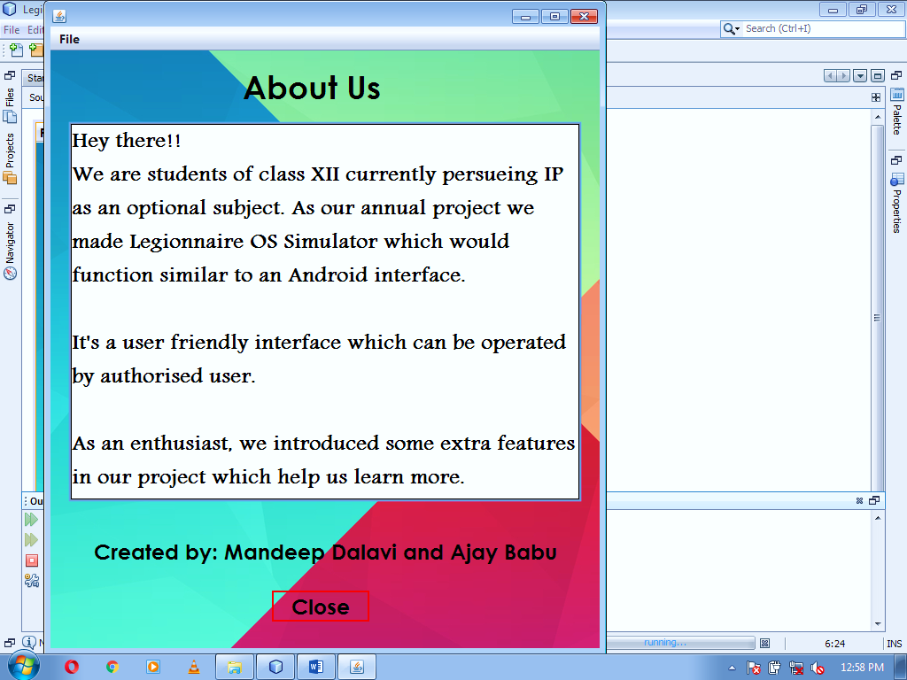

CODING:

package legionnaire_os;

import javax.swing.JOptionPane;

/* @author Mandeep M. Dalavi */

public class About_Us extends javax.swing.JFrame {

public About_Us() {

initComponents();

}

-----------------------------------------------------------------------------------------------------------

private void formWindowActivated(java.awt.event.WindowEvent evt) {

this.setResizable(true);

this.setSize(636, 740);

}

-----------------------------------------------------------------------------------------------------------

private void JumpHomemenuActionPerformed(java.awt.event.ActionEvent evt) {

new Home().setVisible(true);

this.setVisible(false);

}

-----------------------------------------------------------------------------------------------------------

private void JumpAppmenuActionPerformed(java.awt.event.ActionEvent evt) {

new Apps().setVisible(true);

this.setVisible(false);

}

-----------------------------------------------------------------------------------------------------------

private void ExitOSmenuActionPerformed(java.awt.event.ActionEvent evt) {

if(JOptionPane.showConfirmDialog(this, "Are you sure you want to exit?", "Confirmation", JOptionPane.YES_NO_CANCEL_OPTION)==JOptionPane.YES_OPTION)

{ System.exit(0); } }

private void jButton1ActionPerformed(java.awt.event.ActionEvent evt) {

this.setVisible(false);

}

-----------------------------------------------------------------------------------------------------------

**BACKEND TABLES**

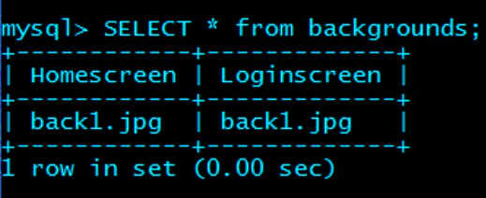**TABLE BACKGROUNDS**

**DESCRIPTION OF BACKGROUNDS TABLE**

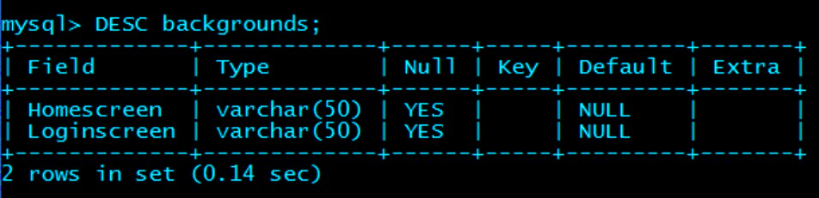

**TABLE BILL**

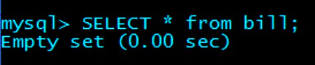

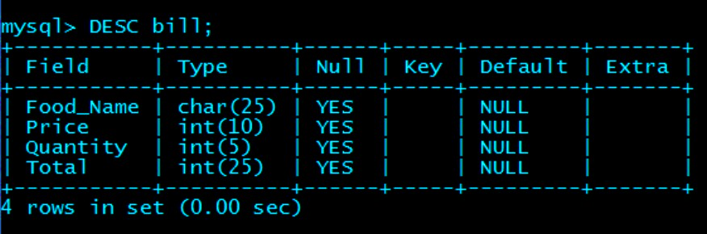**DESCRIPTION OF BILL TABLE**

**TABLE CALLING**

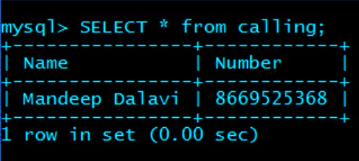

**DESCRIPTION OF CALLING TABLE**

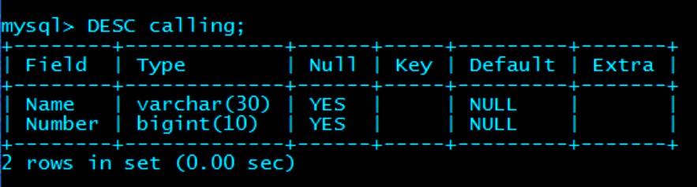

**TABLE CONTACTS**

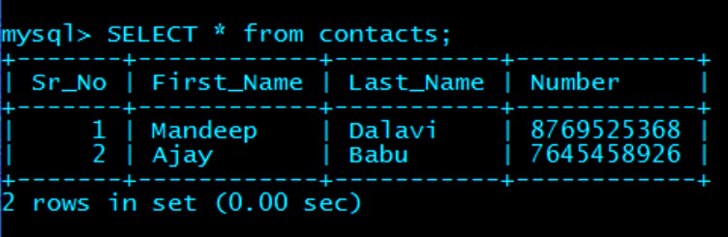

**DESCRIPTION OF CONTACTS TABLE**

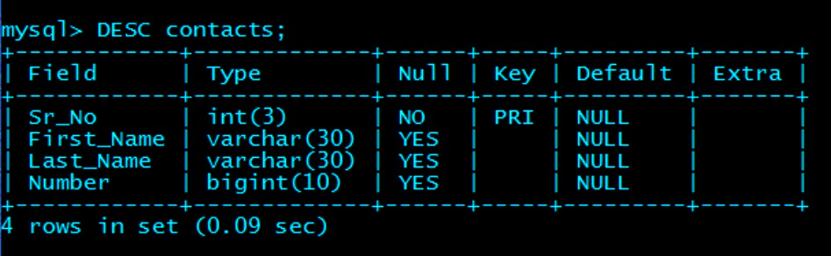

**TABLE SEARCH**

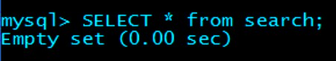

**DESCRIPTION OF SEARCH TABLE**

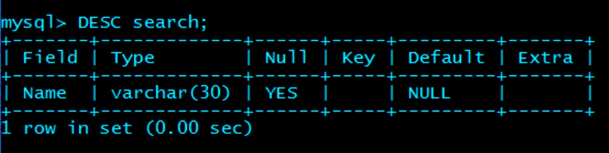

**TABLE USERAVATAR**

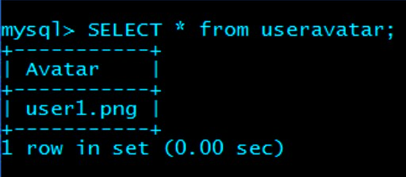

**DESCRIPTION OF USERAVATAR TABLE**

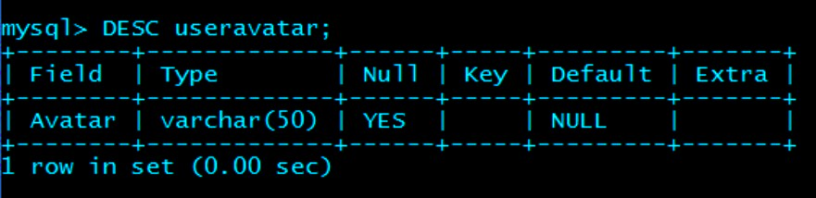

**TABLE USERPASS**

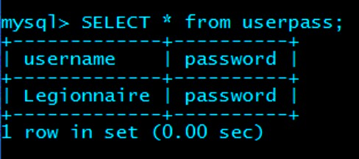

**DESCRIPTION OF USERPASS TABLE**

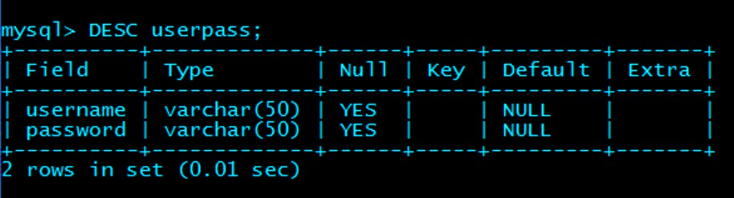

**TABLE WORDS**

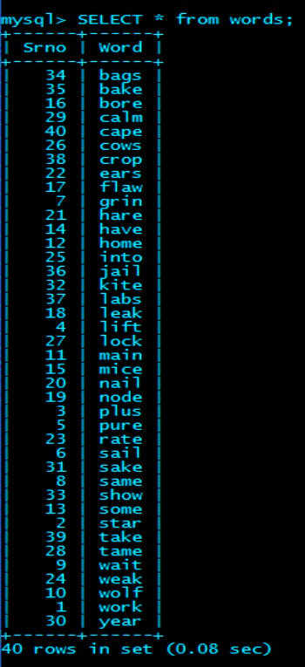

**DESCRIPTION OF WORDS TABLE**

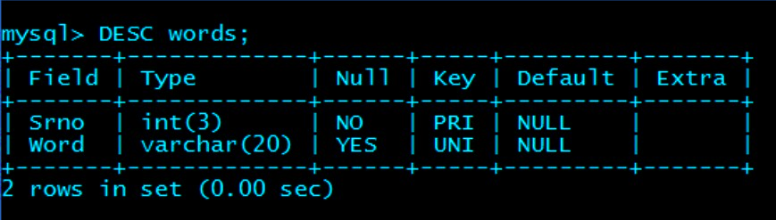

|  |  |  |  |
| --- | --- | --- | --- |
| Sr. No. | Frame | Variable Name | Component Property |
| 01 | Splash | jLabel1 | Font: Century Gothic 36 Bold |
| Foreground: Color-White |
| loadingnum | Font: Cambria Math 24 Bold |
| Foreground: Color-White |
| loadingbar | Foreground: Color-Blue |
| jLabel2 | Icon: giphy (6).gif |
| jLabel3 | Icon: giphy (5).gif |
| Splashlabel | Icon: Picture2.jpg |
| 02 | Login | Hellolabel | Font: Andalus 48 Bold |
| Foreground: Color-White |
| Userlabel | Icon: user12.jpg |
| Usernamelabel | Font: Andalus 24 Bold |
| Foreground: Color-White |
| Passwordlabel | Font: Andalus 24 Bold |
| Foreground: Color-White |
| UserTF | Font: Andalus 24 Bold |
| PassTF | Font: Andalus 24 Bold |
| Foreground: Color-Red |
| Submitbutton | Icon: thick_red (1).png |
| Cancelbutton | Icon: x-mark-3-xxl (1).png |
| Loginlabel | back1.jpg |
| 03 | Home | LegionnaireOSlabel | Font: Andalus 36 Bold |
| Foreground: Color-White |
| Menubutton | Icon: menu--1-.png |
| GrizzlyBearbutton | Icon: icon_billing--1-.png |
| Calculatorbutton | Icon: calculator-icon--2-.png |
| Contactsbutton | Icon: contacts icon.png |
| BullsandCowsbutton | Icon: game icon.png |
| BullsandCowslabel | Font: Andalus 24 Bold |
| Foreground: Color-White |
| Contactslabel | Font: Andalus 24 Bold |
| Foreground: Color-White |
| GrizzlyBearlabel | Font: Andalus 24 Bold |
| Foreground: Color-White |
| Calculatorlabel | Font: Andalus 24 Bold |
| Foreground: Color-White |
| Homelabel | Icon: back3.jpg |
| Homebutton | Icon: home-home-icon (2).png |
| Backbutton | Icon: android-systemback(2).png |
| Powerbutton | Icon: power-xxl (1).png |
| 04 | Apps | Calculatorapp | Icon: calculator-icon--2-.png |
| Contactsapp | Icon: contacts icon.png |
| BullsandCowsapp | Icon: game icon.png |
| GrizzlyBearapp | Icon: icon_billing--1-.png |
| NextPrimeNoapp | Icon: nextprime.png |
| AboutUsapp | Icon: about-us-icon-15 (1).png |
| Settingapp | Icon: settings-I-icon--1-.png |
| BullsandCowslabel | Font: Andalus 24 Bold |
| Foreground: Color-White |
| Contactslabel | Font: Andalus 24 Bold |
| Foreground: Color-White |
| GrizzlyBearlabel | Font: Andalus 24 Bold |
| Foreground: Color-White |
| Calculatorlabel | Font: Andalus 24 Bold |
| Foreground: Color-White |
| NextPrimeNolabel | Font: Andalus 24 Bold |
| Foreground: Color-White |
| AboutUslabel | Font: Andalus 24 Bold |
| Foreground: Color-White |
| Settinglabel | Font: Andalus 24 Bold |
| Foreground: Color-White |
| MoreAppalabel | Font: Andalus 24 Bold |
| Foreground: Color-White |
| Appslabel | Icon: back3.jpg |
| Homebutton | Icon: home-home-icon (2).png |
| Backbutton | Icon: android-systemback(2).png |
| Powerbutton | Icon: power-xxl (1).png |
| 05 | Bulls and Cows | jLabel1 | Font: Century Gothic 36 Bold |
| Foreground: Color-White |
| JLabel(2-16) | Font: Century Gothic 18 Bold |
| Foreground: Color-White |
| jLabel17 | Font: Tahoma 14 Bold |
| Foreground: Color-Red |
| inputTF | Font: Century Gothic 18 Bold |
| jButton1 | Font: Tahoma 18 Bold |
| jButton2 | Font: Century Gothic 24 Bold |
| inputlabel(1-10) | Font: Century Gothic 18 Bold |
| Foreground: Color-White |
| bullslabel(1-10) | Font: Century Gothic 18 Bold |
| Foreground: Color-White |
| cowslabel(1-10) | Font: Century Gothic 18 Bold |
| Foreground: Color-White |
| Bullslabel | Icon: Game back2.jpg |
| Homebutton | Icon: home-home-icon (2).png |
| Backbutton | Icon: android-systemback(2).png |
| Powerbutton | Icon: power-xxl (1).png |
| 06 | Enter No. | JLabel1 | Font: Century Gothic 24 Bold |
| numTF | Font: Tahoma 24 Bold |
| jButton1 | Font: Tahoma 24 Bold |
| 07 | How to Play | jLabel2 | Font: Century Gothic 36 Bold |
| JTextArea1 | Font: Viner Hand ITC 24 Bold |
| Gotit | Font: Matura MT Script 24 Bold |
| Playlabel | Icon: contact back3.jpg |
| 08 | Contacts App | Searchbutton | Font: Andalus 24 Plain |
| Foreground: Color-Blue |
| Recent | Font: Andalus 24 Plain |
| Foreground: Color-Blue |
| Contacticon | Icon: contact user icon.png |
| Contactnumber | Font: Andalus 24 Plain |
| Foreground: Color-Blue |
| Contactname | Font: Andalus 24 Plain |
| Foreground: Color-Blue |
| Callbackbutton | Font: Andalus 24 Bold |
| Foreground: Color-White |
| Searchtext | Font: Andalus 24 Plain |
| Foreground: Color-Blue |
| Addcontactlabel | Font: Andalus 30 Plain |
| firstlabel | Font: Andalus 24 Plain |
| lastlabel | Font: Andalus 24 Plain |
| numberlabel | Font: Andalus 24 Plain |
| Addcontactbutton | Font: Andalus 24 Plain |
| Foreground: Color-Purple |
| firsttext | Font: Andalus 24 Plain |
| lasttext | Font: Andalus 24 Plain |
| numbertext | Font: Andalus 24 Plain |
| srlabel | Font: Andalus 18 Plain |
| first | Font: Andalus 18 Plain |
| last | Font: Andalus 18 Plain |
| number | Font: Andalus 18 Plain |
| firstTF | Font: Andalus 18 Plain |
| lastTF | Font: Andalus 18 Plain |
| numberTF | Font: Andalus 18 Plain |
| Deletebutton | Font: Andalus 18 Plain |
| Updatebutton | Font: Andalus 18 Plain |
| Resetbutton | Font: Andalus 18 Plain |
| Showdetailbutton | Font: Andalus 18 Plain |
| Srenter | Font: Andalus 18 Plain |
| Powerbutton | Icon: power-xxl (1).png |
| Homebutton | Icon: home-home-icon (2).png |
| Backbutton | Icon: android-systemback(2).png |
| Contactbacklabel | Icon: contact back2.jpg |
| 09 | Contact Detail | Call | Font: Tahoma 24 Bold |
| Delete | Font: Tahoma 24 Bold |
| Close | Font: Tahoma 24 Bold |
| Contacticon | Icon: contact user icon.png |
| Contactname | Font: Andalus 24 Plain |
| Foreground: Color-Blue |
| Contactnumber | Font: Andalus 24 Plain |
| Foreground: Color-Blue |
| 10 | Grizzly Bear Login | GrizzlyBearLogo | Icon: grizzy bear.png |
| GrizzlyBear | Font: Andalus 36 Bold |
| Foreground: Color-White |
| Usernamelabel | Font: Andalus 24 Plain |
| Passwordlabel | Font: Andalus 24 Plain |
| Usernametext | Font: Andalus 24 Plain |
| Loginbutton | Font: Andalus 24 Bold |
| Backbutton | Font: Andalus 24 Bold |
| Password | Font: Andalus 24 Plain |
| Foreground: Color-Red |
| GrizzlyBearlabel | Icon: app back1.jpg |
| Homebutton | Icon: home-home-icon (2).png |
| Backbutton 1 | Icon: android-systemback(2).png |
| Powerbutton | Icon: power-xxl (1).png |
| 11 | Grizzly Bear Menu | FoodNamelabel | Font: Century Gothic 24 Bold |
| FoodTypelabel | Font: Century Gothic 24 Bold |
| Pricelabel | Font: Century Gothic 24 Bold |
| Quantitylabel | Font: Century Gothic 24 Bold |
| Amountlabel | Font: Century Gothic 24 Bold |
| FoodName | Font: Century Gothic 24 Bold |
| FooType | Font: Century Gothic 24 Bold |
| Price | Font: Century Gothic 24 Bold |
| Quantity | Font: Century Gothic 24 Bold |
| Amount | Font: Century Gothic 24 Bold |
| MenuItemlebel | Font: Century Gothic 24 Bold |
| Drinks | Font: Century Gothic 15 Bold |
| Sandwich | Font: Century Gothic 15 Bold |
| Chapatti | Font: Century Gothic 15 Bold |
| Rice | Font: Century Gothic 15 Bold |
| SouthIndian | Font: Century Gothic 15 Bold |
| ShakahariKhazana | Font: Century Gothic 15 Bold |
| Soup | Font: Century Gothic 15 Bold |
| Dal | Font: Century Gothic 15 Bold |
| Western | Font: Century Gothic 15 Bold |
| Breakfast | Font: Century Gothic 15 Bold |
| AddBillbutton | Font: Century Gothic 24 Bold |
| ShowBillbutton | Font: Century Gothic 24 Bold |
| GrizzlyBearMenu | Font: Century Gothic 30 Bold |
| menulabel | Icon: Wallpaper-white-21.jpg |
| Homebutton | Icon: home-home-icon (2).png |
| Backbutton | Icon: android-systemback(2).png |
| Powerbutton | Icon: power-xxl (1).png |
| 12 | Grizzly Bear Bill | YourBill | Font: Century Gothic 30 Bold |
| TotalAmountlabel | Font: Century Gothic 24 Bold |
| TotalAmount | Font: Century Gothic 24 Bold |
| PlaceOrderbutton | Font: Century Gothic 24 Bold |
| GrizzlyBearbilllabel | Icon: Wallpaper-white-21.jpg |
| Homebutton | Icon: home-home-icon (2).png |
| Backbutton | Icon: android-systemback(2).png |
| Powerbutton | Icon: power-xxl (1).png |
| 13 | Calculator App | Onebutton | Font: Tahoma 20 Bold |
| Twobutton | Font: Tahoma 20 Bold |
| Threebutton | Font: Tahoma 20 Bold |
| Fourbutton | Font: Tahoma 20 Bold |
| Fivebutton | Font: Tahoma 20 Bold |
| Sixbutton | Font: Tahoma 20 Bold |
| Sevenbutton | Font: Tahoma 20 Bold |
| Eightbutton | Font: Tahoma 20 Bold |
| Ninebutton | Font: Tahoma 20 Bold |
| Zerobutton | Font: Tahoma 20 Bold |
| x2button | Font: Tahoma 20 Bold |
| Dividebutton | Font: Tahoma 24 Bold |
| Multiplybutton | Font: Tahoma 24 Bold |
| DotButton | Font: Tahoma 20 Bold |
| ACbutton | Font: Tahoma 20 Bold |
| Deletebutton | Cambria Math 48 Bold |
| Subtractbutton | Font: Tahoma 36 Bold |
| Addbutton | Font: Tahoma 24 Bold |
| Equalbutton | Font: Tahoma 24 Bold |
| Input | Font: Tahoma 18 Bold |
| Logbutton | Font: Tahoma 20 Bold |
| Cosbutton | Font: Tahoma 20 Bold |
| Sinhbutton | Font: Tahoma 20 Bold |
| Coshbutton | Font: Tahoma 20 Bold |
| Tanbutton | Font: Tahoma 20 Bold |
| xybutton | Font: Tahoma 20 Bold |
| Sinbutton | Font: Tahoma 20 Bold |
| Sqrtbutton | Font: Tahoma 20 Bold |
| Tanhbutton | Font: Tahoma 20 Bold |
| x3button | Font: Tahoma 20 Bold |
| piebutton | Font: Felix Titling 20 Bold |
| Plusminusbutton | Font: Cambria Math 18 Bold |
| Cbrbutton | Font: Tahoma 20 Bold |
| Roundbutton | Font: Tahoma 20 Bold |
| Hexbutton | Font: Tahoma 20 Bold |
| Binbutton | Font: Tahoma 20 Bold |
| Modbutton | Font: Tahoma 20 Bold |
| lnxbutton | Font: Tahoma 20 Bold |
| Degbutton | Font: Tahoma 20 Bold |
| Radbutton | Font: Tahoma 20 Bold |
| Octalbutton | Font: Tahoma 20 Bold |
| Calculatorlabel | Icon: back26.jpg |
| Homebutton | Icon: home-home-icon (2).png |
| Backbutton | Icon: android-systemback(2).png |
| 14 | Next Prime No. | Enternolabel | Font: Century Gothic 24 Bold |
| Nextnolabel | Font: Century Gothic 24 Bold |
| Nextno | Font: Century Gothic 24 Bold |
| Submit | Font: Century Gothic 24 Bold |
| Clear | Font: Century Gothic 24 Bold |
| Enterno | Font: Century Gothic 24 Bold |
| NextPrimeNolabel | Icon: Wallpaper-white-21.jpg |
| Homebutton | Icon: home-home-icon (2).png |
| Backbutton | Icon: android-systemback(2).png |
| Powerbutton | Icon: power-xxl (1).png |
| 15 | Setting App | ChBackbutton | Font: Century Gothic 24 Bold |
| Icon: displaysetting.png |
| ChAvatarbutton | Font: Century Gothic 24 Bold |
| Icon: Changeuser.png |
| SecurSetbutton | Font: Century Gothic 24 Bold |
| Icon: passicon.png |
| Settinglabel | Icon: back20.jpg |
| Homebutton | Icon: home-home-icon (2).png |
| Backbutton | Icon: android-systemback(2).png |
| Powerbutton | Icon: power-xxl (1).png |
| 16 | Change Background | homeback(1-18) | Icon: back(1-18) icon.jpg |
| loginback(1-18) | Icon: back(1-18) icon.jpg |
| Loginbacklabel | Font: Century Gothic 24 Bold |
| Foreground: Color-Blue |
| Homebacklabel | Font: Century Gothic 24 Bold |
| Foreground: Color-Blue |
| changebacklabel | Icon: back19.jpg |
| Homelabel | Icon: home-home-icon (2).png |
| Backlabel | Icon: android-systemback(2).png |
| Powerlabel | Icon: power-xxl (1).png |
| 17 | Change Avatar | User(1-15)button | Icon: user(1-15).png |
| changeavatarlabel | Icon: back19.jpg |
| Homelabel | Icon: home-home-icon (2).png |
| Backlabel | Icon: android-systemback(2).png |
| Powerlabel | Icon: power-xxl (1).png |
| 18 | Security Setting | Securitylabel | Font: Century Gothic 48 Bold |
| ChangeUserlabel | Font: Century Gothic 24 Bold |
| ChangePasslabel | Font: Century Gothic 24 Bold |
| CurUserlabel | Font: Century Gothic 24 Bold |
| CurPasslabel | Font: Century Gothic 24 Bold |
| NewUserlabel | Font: Century Gothic 24 Bold |
| Curuserlabel | Font: Century Gothic 24 Bold |
| Curpasslabel | Font: Century Gothic 24 Bold |
| Newpasslabel | Font: Century Gothic 24 Bold |
| CurUserleft | Font: Century Gothic 24 Bold |
| NewUserleft | Font: Century Gothic 24 Bold |
| NewPassright | Font: Century Gothic 24 Bold |
| CurUserright | Font: Century Gothic 24 Bold |
| Submitright | Font: Century Gothic 24 Bold |
| Submitleft | Font: Century Gothic 24 Bold |
| CurPassleft | Font: Century Gothic 24 Bold |
| Foreground: Color-Red |
| CurPassright | Font: Century Gothic 24 Bold |
| Foreground: Color-Red |
| SecurSetlabel | Icon: settingback3.png |
| Homebutton | Icon: home-home-icon (2).png |
| Backbutton | Icon: android-systemback(2).png |
| Powerbutton | Icon: power-xxl (1).png |
| 19 | About Us | AboutUs | Font: Century Gothic 36 Bold |
| AboutContent | Font: Andalus 24 Bold |
| Createdbylabel | Font: Century Gothic 24 Bold |
| Closebutton | Font: Century Gothic 24 Bold |
| AboutUslabel | Icon: contactback4.jpg |

**BIBLIOGRAPHY**

* Class XII NCERT Informatics Practices
* Class XII Informatics Practices-Sumita Arora
* Image Courtesy:
* Google Images
* Pexels
* Giphy
* Unsplash
* Zedge
* Youtube:
* <http://youtu.be/1NbTjFx3ti8>
* <http://youtu.be/ZXToPivlR84>
* <http://youtu.be/oxT2G4gxsxc>
* Hackerank, Code Chef & Udemy
* Help from Teachers and Friends